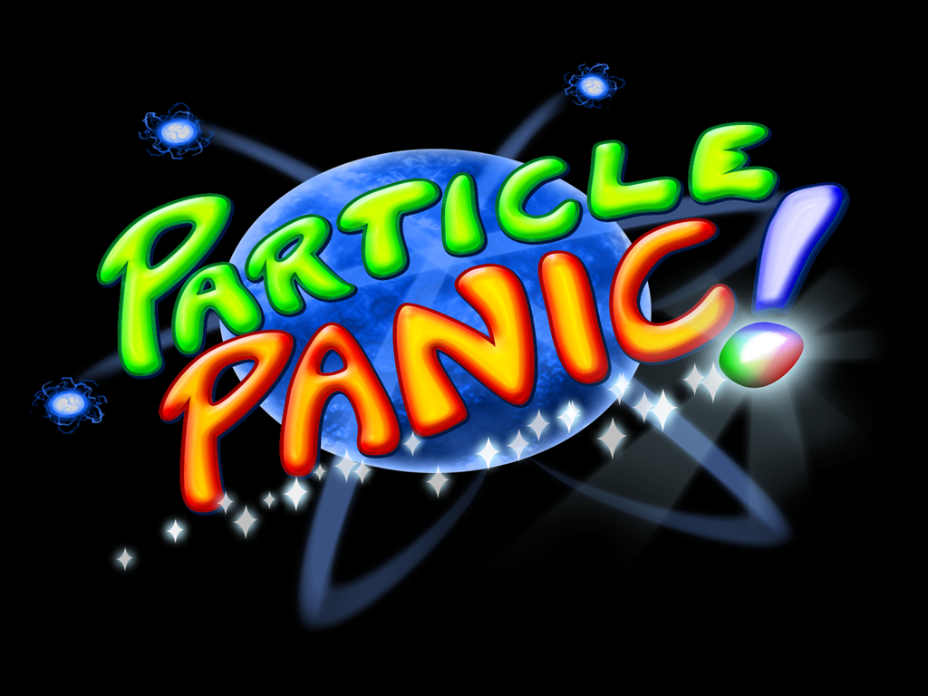

Andrew Zeck – andrewzeck@gmail.com
Dustin Berkey – drberkey@fullsail.edu
Jacob Yelinek – jacobyelinek@yahoo.com
Michael Tomasino – mtomasino@hotmail.com
J Domagala – jdomagala@fullsail.edu
Tom Cassera – tom.cassera@gmail.com





Game Charter 1
Vision Statement 1
Meeting Schedule 1
Hours Worked per Week 1
When Things Go Wrong 1
Decision-Making Process 2
Rules of Conduct 2
Team Roles 3
Executive Summary 4
High Concept 4
Locale 4
Genre 4
Basic Controls 4
Game Goal 5
Target Platform 6
Marketing & Target Audience 6
Game Walkthrough/Overview 6
Key Features 7
Comparative Products 7
How this Product Stacks up 7
Treatment 8
Dust Jacket Story 8
Game Story 8
Characters 9
Art and Production Design 10
Art & Animation Style 10
Sound Effects Style 11
Music Style 11
Storyboards and Sample Art 12
Interactivity 17
Goal 17
Interface 18
Interactive Rhythm 23
How the Player Marks Progress 23
Detailed Design Breakdown 25
Front End Flow Chart 25
Front End Flow Chart Cont. 26
Game Flow Chart 27
Glossary of Terms 28
Characters 30
Power-ups 35
Levels and Maps 36
Interactive System 40
Special Abilities 42
Game Logic, Algorithms, and Rules 43
Interaction Component Matrix 43
Key Game Algorithms 43
FAQ 46
Reference of Key Elements 48
Scoring 48
Winning/Losing 48
Transitions 48
Art and Production Design 49
3D Art & Animation Deliverables 49
2D Art (HUD/Menu/Particle/Textures) Deliverables 49
Sound Effects Deliverables 50
Music Deliverables 51
Coding Standards 52
Naming Standards 52
Prefix Convention 52
Classes 52
Relevant Function Names 53
Macros and Constants 53
Commenting 53
Coding Guidelines 54
Development Environment 55
System Architecture 56
Context Model Description 57
System Feature Breakdown 61
Renderer 61
Texture Manager 63
Shader Manager 64
Mesh Manager 65
Input Manager 66
Physics Engine 70
Camera 72
Menu System 75
Object Manager 77
Font Manager 79
Sound Engine 81
Wave Manager 83
Particle Manager 84
Game Feature Breakdown 85
HUD 85
Game Class 87
Game State Machine 88
Player Class 90
Player State Machine 93
Level Module 95
Player Profile System 99
Milestone Deliverables 101
Feature Fragment 1 101
Feature Fragment 2 101
Alpha 101
Beta 101
Memory Map 101
Integration Plan 103
Testing Plans 104
Game Folder Hierarchy 105

Game Charter

Vision Statement

We will deliver and complete a polished title in 5 months by maintaining effective communication, being honest with each other, and keep open minds and ears to all group members. We will create realistic schedules by analyzing individual skills and appropriately portioning time. We will strive to complete assigned individual tasks by deadlines, and go out of our way to help members running behind by offering assistance and redistributing work loads. By adhering to our design document we will create a finished product that will be the representation of our cumulative goals and ideas.

Meeting Schedule

We will meet up 4-5 times a week (not including class days) at a group member’s apartment or at the school. Meetings will begin at 1pm but are subject to change if problems arise. The project lead will start the meeting and bring all members up to date on the current progress of the group as a whole. We will discuss any individual issues we are having on assigned tasks and address group concerns. Each team member is required to be present and participate in the meeting and state their current progress. If someone needs extra help, we will divide work loads accordingly. These meetings will not exceed one hour in length.

Hours Worked per Week

Each team member is required to work 50 hours per week. No one will exceed a 60 hour work week. We will work as a group 8 hours a day, 5 days a week, and every member is responsible to work another 10 hours at their leisure, individually or with others.

When Things Go Wrong

If a group member has an emergency they will contact the project lead by phone, who will subsequently contact the other members. We will avoid risks if an emergency arises by keeping each member up to date on our situations and what work needs to be done

Decision-Making Process

Concerning a decision that will affect the entire project, everyone will be notified and informed on the change at the next group meeting. The group will have to unanimously agree on the decision before it is implemented. If this discussion exceeds a half hour in length, an alternate choice or compromise must be agreed upon or the issue will be brought to our EP for the final decision.

Rules of Conduct

1. Treat all team members with respect (no insulting, shouting, bickering, physical aggression).

2. Keep personal problems at home. Maintain a professional atmosphere.

3. Leave your ego at the door.

4. Hygiene is paramount.

5. Don’t be more than 10 minutes late for meetings or work sessions.

6. Notify all members in a minimum of 5 days in advance of any pre-planned activity.

7. Every other week take some time off to spend with the group and do a fun activity together.

8. If two group members are having personal issues, contact the project leader for mediation. If any group member has a problem with the project leader feel free to discuss it with him, if necessary the issue will be brought to our EP.

9. Be completely honest with yourself and your teammates. State your abilities as accurately as possible. Don’t hesitate to ask for help.

10. Commit yourself to the project and your teammates in the fullest degree possible.

Anytime a rule is broken, it is recorded at that time by the project lead and signed off by the offender (even if it is the project lead). If these rules are broken three times in a week by one member, the project lead will notify the EP and proper consequences will be discussed.

Team Roles

Project Lead – Andrew Zeck
Technical Lead – Michael Tomasino
Asset Lead – J. Domagala
Gameplay Lead – Tom Cassera
Q & A Lead – Jacob Yelinek
Design Lead – Dustin Berkey
Executive Summary

High Concept

Navigate through a quantum world to build the atomic bonds that will save the universe.

Locale

Particle Panic! takes place in the quantum universe, where the player will be creating bonds between atoms. The atoms will be one of three colors: red, green, or blue. Also, each atom will have several electrons with similar color schemes swirling around it, much like you see in science books. Since the quantum universe is not fully explored, the backgrounds and art styles will be very abstract, with liberal use of swirling colors and bright, almost neon particles whizzing around the world. The general theme of the game, much like real quantum physics, is controlled chaos.

Genre

3-d Puzzle

Basic Controls

The player controls Quark, the main character of the game. The player has the ability to maneuver the camera in a 3rd person perspective with the mouse/joystick. When Quark is moving about in atomic space, the camera is focused on the quark. When the Quark is locked in orbit around an atom, the camera will be focused on the atom. The player is also able to zoom out to view the entire map. In this mode the camera control will maintain consistency, allowing the player to view the map in a 3D 3rd person perspective.
A button will toggle the Quark navigation and collection mode. An activation button will initiate the proper activity, such as gravitation in navigation mode and sucking in electrons in collection mode. A deactivation button will do the opposite, turning off the polarity attributes in navigation mode, and releasing electrons in collection mode. The player is permitted to pause the game at any time with a button press.

Game Goal

The overall goal of the game is to go navigate through the level and solve the puzzle which is based on the puzzle type of that level. Once the player solves the current puzzle, the road to the next stage will open and the player may continue on. Each level’s puzzle could be one of two types:

Builder:
In the builder puzzle, the player is assigned a certain number of each color of atom that needs to be in their final molecule. The player can connect any atom with any other atom and has free roam to complete the task as they wish.

Time Attack:
The time attack mode is just like the builder, where the player is given a specific number of atoms of each color that they must have in their final molecule. The difference is that there is a time limit in which they must complete the task. The time will vary depending on the difficulty of the given puzzle.
Target Platform

Primary Platform
- Windows based PCs

Minimum Requirements:
- Windows System 2000/XP OS
- Intel Pentium IV 1.5 GHz or AMD XP 1500+ MHz
- 512 MB RAM
- 64 MB 3D graphics card with Hardware Transform and Lighting, such as NVIDIA GeForce FX 5700 class card or above
- Two-button scroll-wheel mouse

Secondary Platform
- Xbox 360 (XBLA)

Marketing & Target Audience

We are aiming towards 16-35 year old males and 35-50 year old females, who are casual gamers. For the 16-35 males, these include people in high-school, college, or a job who cannot sit down and spend hours a day playing a game. We are allowing them to sit down, play for a few minutes, and relax. The majority of puzzle game players are 35-50 year old females, therefore our target is feasible.

Game Walkthrough/Overview

The player will start at a random position in the level, from where they must select a polarity which will cause them to gravitate toward the nearest atom of that same polarity. This essentially starts the game’s navigation. Once the player is moving, they then must move from atom to atom by either utilizing the action button, which will increase their speed and give them a specific direction in which to launch themselves, or by simply changing their polarity.
Once the player reaches the atom they desire, they can start collecting the electrons that orbit that atom. After they acquire all of the electrons they need, they will navigate to another atom that they would like to bond to. They then release the electrons they initially collected, and repeat the collection process with this new atom, eventually returning to the previous atom.
After the electrons are balanced between the two atoms, a bond will be formed, pulling each atom, sometimes violently, towards each other. The player will repeat this process, forming bonds and pulling different atoms together until the level’s end goal is reached.

Key Features

Gameplay “A” Features:
  - Gravitational movement
  - Item Collection
  - Strategic Building

Gameplay “B” Features:
  - Dark matter hazards
  - Power-Ups
  - Varied game modes

Comparative Products

Scorched Planets
Super Mario Galaxy

How this Product Stacks up

The similarities between Particle Panic! and Mario Galaxy are only found in a few levels of Mario Galaxy where gravity platforms attract Mario towards them. Mario can jump over the side of one of these platforms and wind up on the other side due to the gravity. Also, he can have his path be changed if he jumps to close to other gravitational platforms. Particle Panic! will have this gravitational pull but instead of the player walking and being planted on the edge of the objects he will be in orbit of atoms he’s being pulled towards.
With Scorched Planets the projectiles are attracted to planets and hopefully slam into the enemy planets. If the projectiles are attracted to planets but don’t collide, the path has been effected and may cause them to be attracted to a different planet. This is how Quark in Particle Panic! is going to travel, but we don’t want to have Quark slam into the atoms but rather orbit them and continue to move to other atoms.
Treatment

Dust Jacket Story

The universe is falling to pieces and only Quark can save it! It’s up to Quark to travel through atomic space by using his magnetic pull towards other atoms. Help Quark transfer and balance electrons to reform bonds between atoms and prevent the tearing of the universe!

Game Story

Dark matter has begun to spread into your world. It’s disturbing and destructive force is wreaking utter chaos at the atomic level! In the midst of this quantum pandemonium, a mysterious quark with extraordinary powers has emerged. With the ability to manipulate all the sub-atomic forces, it has the power to reform bonds between atoms and restore natural order. The quark, cleverly named Quark, is the last hope for balance in the universe. He traverses the unfamiliar world by traveling from cluster to cluster of molecules and collecting electrons. Using these collected electrons, Quark places them at the right atomic particles to create equilibrium and reform the bonds essential to holding the elements together. After navigating this hectic environment, Quark uses his powers and skills to repair the threads that maintain atomic order and returns the universe to its peaceful state.
Characters

Name/ID
Quark

Brief Description
Quark is the representation of the player inside of the game world. He is whom the player uses to perform all of the actions required to build molecules and complete the game’s goals.

Visual Design
Quark is a blob like entity. He is a collection of three spheres colored red, green, and blue, that mold and combine with each other in a semi-random fashion. He has a faint glow of the color his certain polarity is set to. When he is neutral or inactive, he will have no glow emanating from him.

Back Story
He was formed in the utter chaos of the sub-atomic turmoil.

Dialogue
Quark has no dialogue.

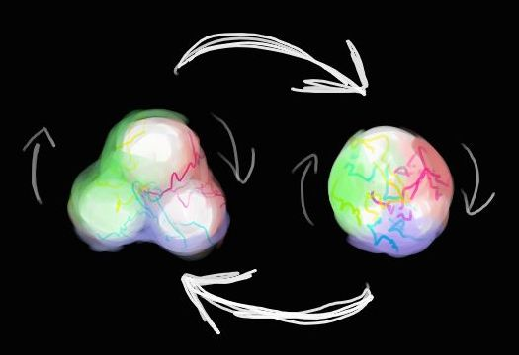
Art and Production Design

Art & Animation Style

All of the 3D deliverables for Particle Panic! will be spheres except the Dark Matter, which will be a gelatinous blob of black and purple made out of a cube with shaders applied.
For the HUD, we will need three circular displays that will look similar to our atoms in the game itself. Each of these displays will have a numerical display inside telling the player how many more of the corresponding color they need. We will also need a circular display broken into three parts for the polarity wheel (red, green and blue) and an arrow that we can move over it to adjust the visual output. The colors should gradient into each other. We will need a horizontal tube-like display that will fill and ebb with our energy count. The filled portion should be neon yellow.
For our models we will need textures that reflect the ambient, energetic feel of our game. We will need them for the three main atoms: red, green and blue. They should also look appropriate with higher levels of alpha, as we are planning to have them translucent. We will also need a background for our ‘particle universe’ that is unobtrusive but compliments the style of the other graphics. It should be dark, predominantly black, but have colored area to give it a sense of depth. This should not be so bright as to clash with the atoms, but should break up the monotony.
For the menu, we will need a simple, clean, round font that we will be able to use for bitmapping our text. It should be easy to read, but not clash with the other visuals, as we will be overlaying the menu at points with our other graphics. It should also be able to be resized properly without any graphical artifacts present or abnormalities in display.

Sound Effects Style

Similar to the music, the sound effects should be mostly of a serene nature, very round and warm, and give the feeling of energy. There should be sound effects when in the area of effect of the atoms that gives the impression of being enveloped by calm, warm energy. When bonds are formed, however, there will be a visual electrical discharge, and that should be a very sharp and natural electrical sound. When picking up the electrons, they should make a soft popping noise, simply to alert the player that they have acquired them. A similar noise should designate their dropping, just at a lower tone. The menu will also feature this sort of soft pop to assure the player they have arrived at a new item. The only sound that needs to be intentionally harsh will be the one associated with running into the Dark Matter. The sound associated with it should be sharp and make the player uncomfortable with having done this. We will also need a sharp beeping sound for when the energy gauge is nearly depleted.

Music Style

The music in Particle Panic! will be ambient techno. When the player is in a Builder mode, the feel of the music with be tranquil and trance-like. This will help to create an explorative atmosphere for the player, making them feel at ease with what they are doing. In the time attack mode, the mood of the music will change to a more upbeat, intense, and hardcore style. This will give the player a sense of urgency. As time runs down, more tracks will be overlaid to alert the player of time running out.

Example Songs
- Inbetween Your Choice – 16B
- Keep On Changing Shape – 16B
- Colours – 16B

Storyboards and Sample Art
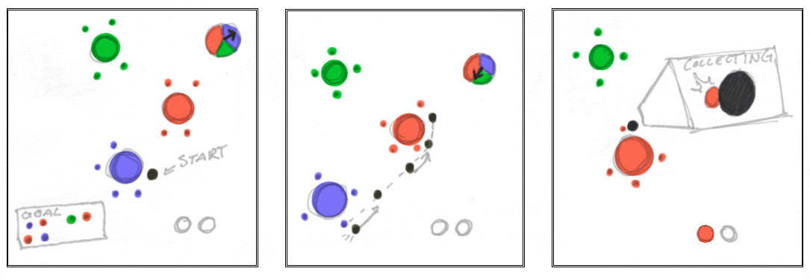
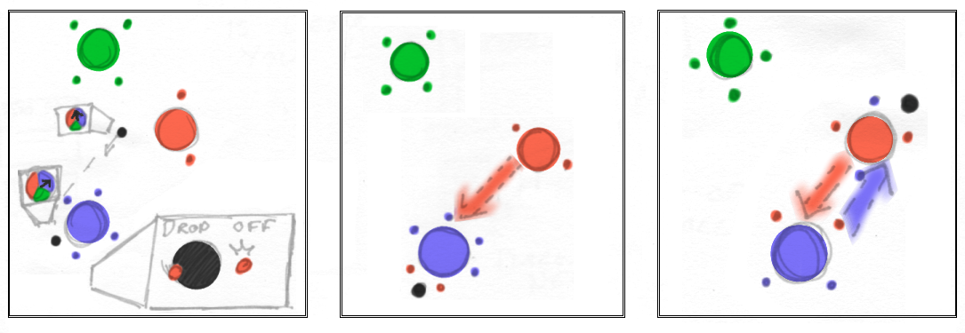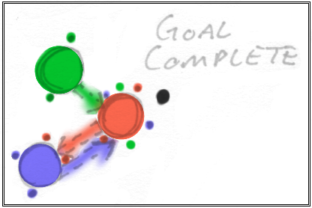
Sample Level Walkthrough
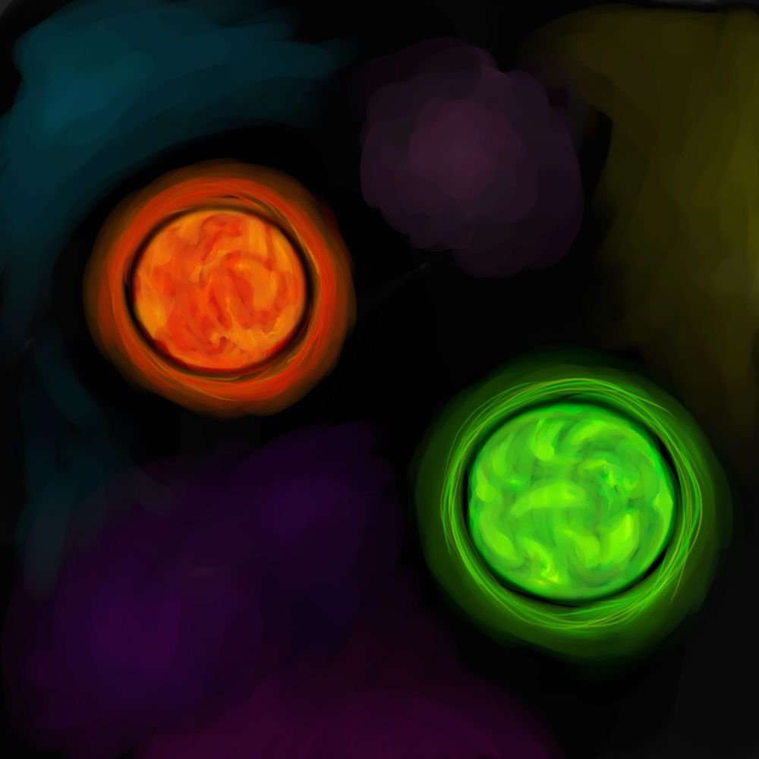
Red and Green Atoms

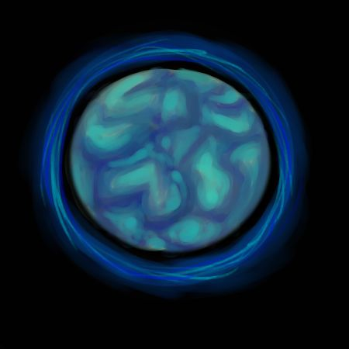
Blue Atom
Quark (with implied shader animation)

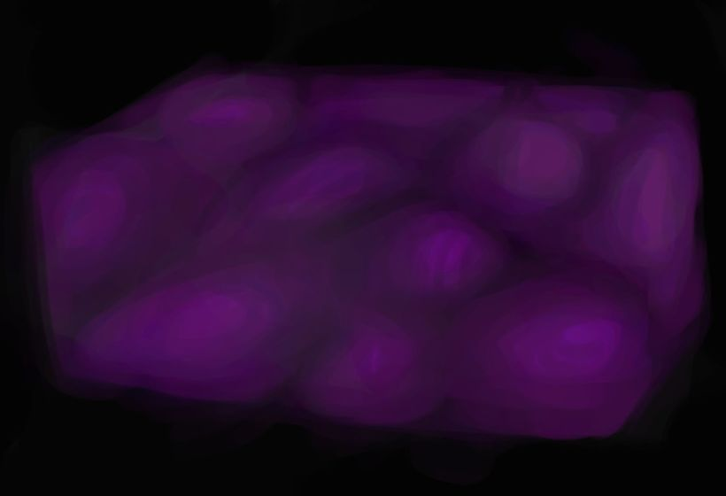
Dark Matter (with implied shader morphing)

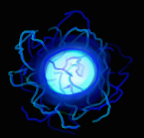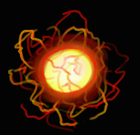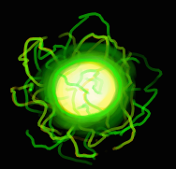
Blue, Red and Green Electrons

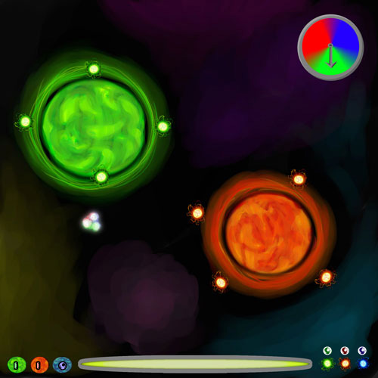
Navigation Mode HUD Mock-Up
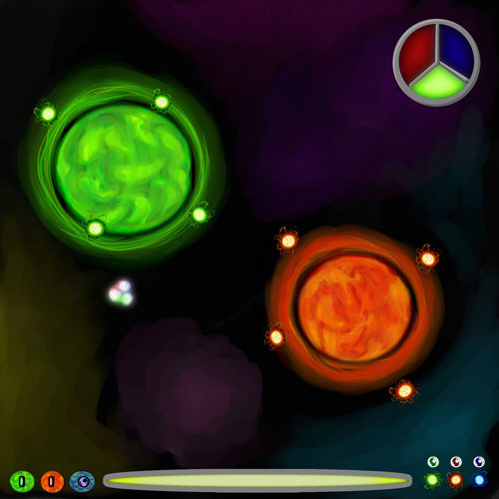
Collection Mode HUD Mock-Up

Interactivity

Goal
The overall goal of the game is to navigate and solve the corresponding puzzle that lies within each level. Once the player solves one puzzle the road to the next stage will open and the player can continue on. Each level’s puzzle could be of three types:

Builder:
- Player is assigned an amount of red, green, and blue atoms.
- Player can navigate the world and connect atoms in any way the want.
- The resulting molecule must have the exact number of red, green and blue atoms in it.
- There is no specific shape the player must create.

Time Attack:
- The player must complete a Builder mode in a certain amount of time.
- Time will vary depending on the difficulty of the given puzzle.
Interface
The game’s menus will be represented by 3D molecules that will have a different option on each atom. The molecule will rotate when you highlight a different option. When you actually select an option the molecule will burst apart and then reform into the new menu. Once the user has selected the sub-most level of the menu, electrons will orbit it representing the individual options of that submenu.

Our menus include:

Main Menu
- Profiles
- Achievements
- Campaign
  - Visual representation of levels as atoms.
  - Bonds will form current level to the next on completion.
  - Player must complete current level to select the next.
- Options
- Credits
- Exit

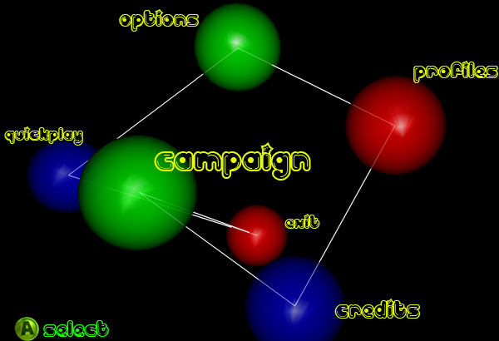

Options Menu
- Music Volume
- Sound Effect Volume
- Gamma
- Controls
- Back

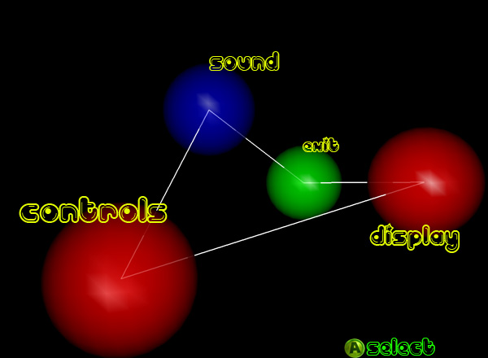

Campaign Menu

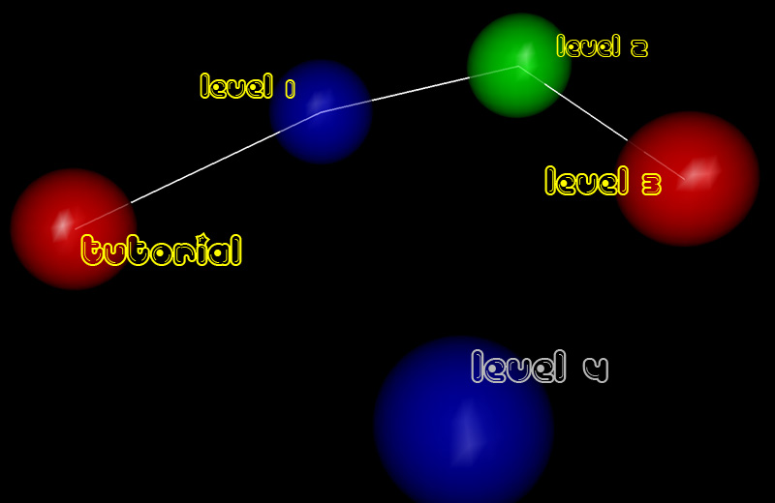

HUD
- Energy bar
  - Bottom center of screen.
  - Decreases when player uses the action button.
- Polarity Wheel
  - Bottom right hand corner of the screen.
  - Shows the player’s current polarity.
  - A pointer turns as player adjusts polarity.
- Builder Goal
  - Only exists in Builder mode.
  - 3 colored spheres corresponding to amount and color of atoms needed to complete the goal.
- Time
  - Only visible in Time Attack mode.
  - Top-Center of the screen.

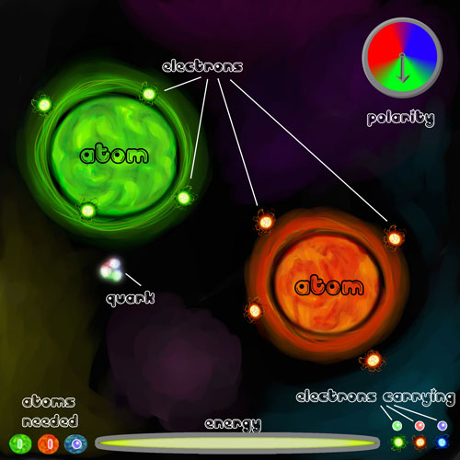
Navigation Mode HUD
Control Scheme
- Xbox360 Controller
  - Left Trigger - Neutral button
  - Left Bumper – Toggle Camera (3rd person/World view)
  - Left Stick – Change Polarity
  - Right Trigger – Action button
  - Right Bumper – Toggle State (Navigation/Collection)
  - Right Stick – Rotate Camera
  - A button – Select (menu items)
  - Start – Pause game

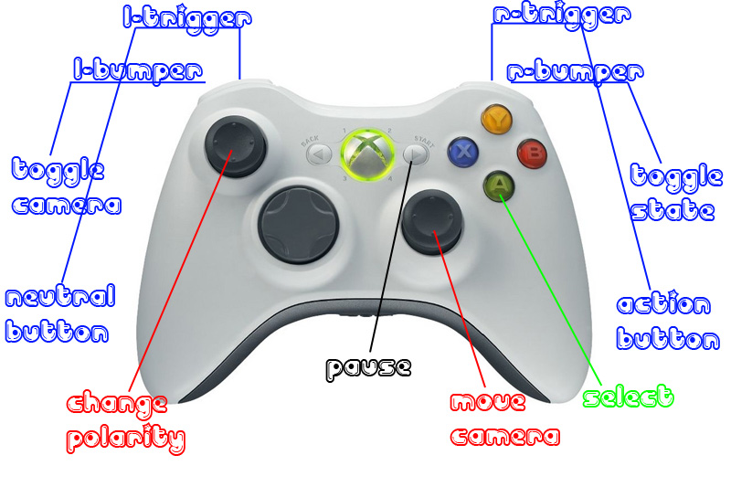

Keyboard
- Mouse Wheel – Change polarity
- Left Click – Action button/Select
- Right Click – Neutral button
- Spacebar + Mouse movement – Rotate Camera
- Tab – Toggle State (Navigation/Collection)
- Left Shift – Toggle Camera (3rd person/World view)
- Escape– Pause game
Interactive Rhythm
- Each level will last around 5-10 minutes.
- The game as a whole will be able to be completed in about 60 minutes.
- An average player’s game play will consist of three parts:
  - Navigate
    - The player, already having looked at the goal of the level, will move to the next atom that they need to bond or gather electrons from.
    - Average time to complete: 10 seconds
  - Collect/Drop Off
    - The player will either need to collect or release electrons on the atom in order to progress to the next phase of bond forming.
    - Average time to complete: 5 seconds
  - Form bond
    - Once the required number of electrons has been distributed between two atoms, a bond will be formed.
    - Average time to complete: 3 seconds
- The player will repeat these steps in order to progress through each level, having an overall average game play pace of between 15 and 20 seconds.

How the Player Marks Progress

On the campaign screen, levels will be represented as atoms with a preview of each level inside. Once a player beats a level, a bond will be formed from that level to the next, similar to the bonds formed in actual game play. Progress within each level depends upon the current levels game mode.
The Builder mode is non-linear progression, so the only visual representation will be three spheres of blue, red, and green, with respective numbers of required atoms to be in the final molecule.
Lastly, the Time-Attack mode will have the same progression as the previous two modes, but with the added challenge of finishing them in the time required, which will be displayed at the top of the screen.
Achievements
Throughout Particle Panic the player will be able to unlock certain achievements which they can view on the Achievements screen.

- Evasive Maneuvers
  - Avoid all Dark Matter in a level
- Polarity Pro
  - Don’t collide with any atoms or walls
- Valence Master
  - Create the maximum bonds available on an atom
- Solo Artist
  - Beat a level without any getting any power-ups
- Death Wish
  - If the player finishes a level and goes through Dark Matter 5 times or more
- Close Call
  - Complete a level with less than 10% energy remaining.
- Lab Assistant
  - Make 10 bonds in the game overall
- Journeyman
  - Make 25 bonds in the game overall
- Crazy Chemist
  - Make 50 bonds in the game overall
- Mad Scientist
  - Make 100 bonds in the game overall
- Completionist
  - Beat all of the levels.
- Over-Achiever
  - Complete all of the levels and obtain all other achievements.

Detailed Design Breakdown
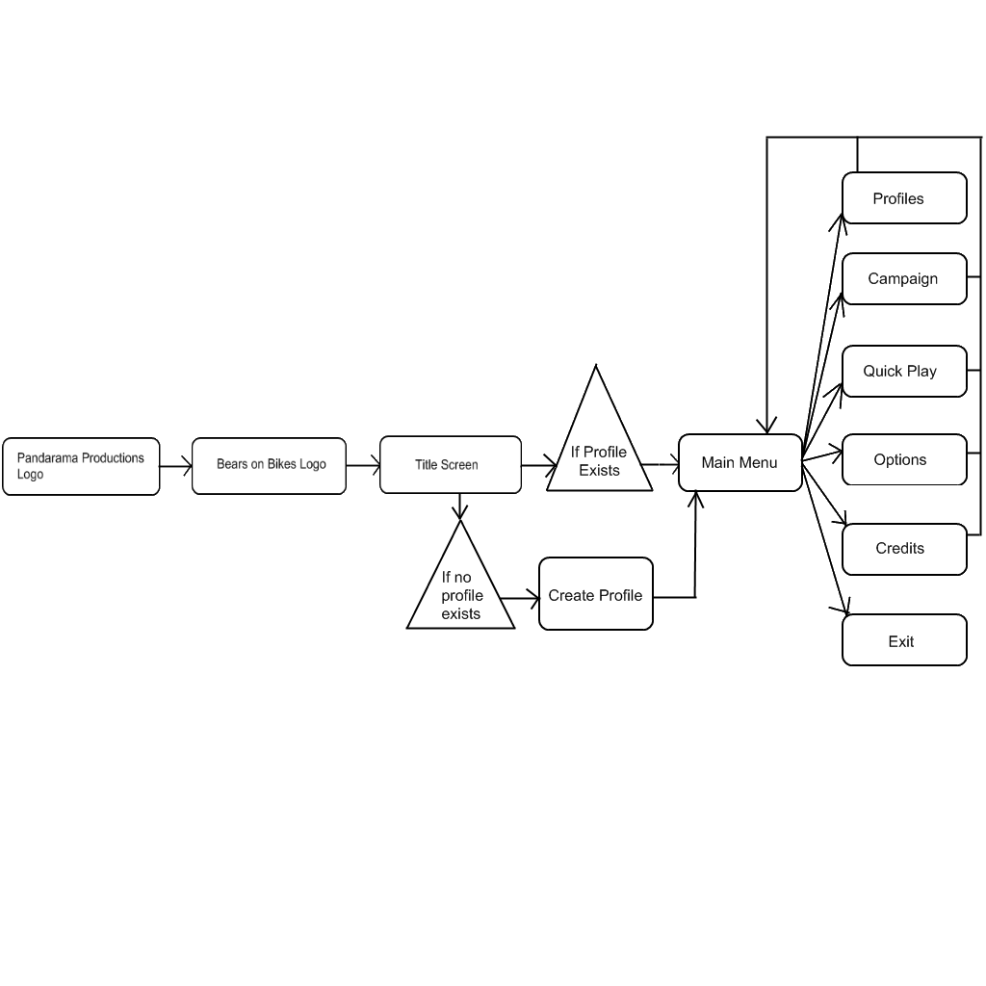
Front End Flow Chart

Front End Flow Chart Cont.

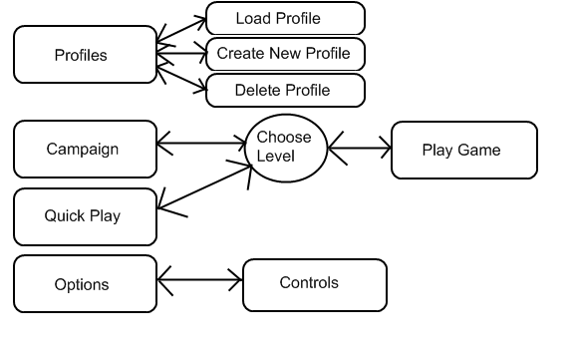

Game Flow Chart
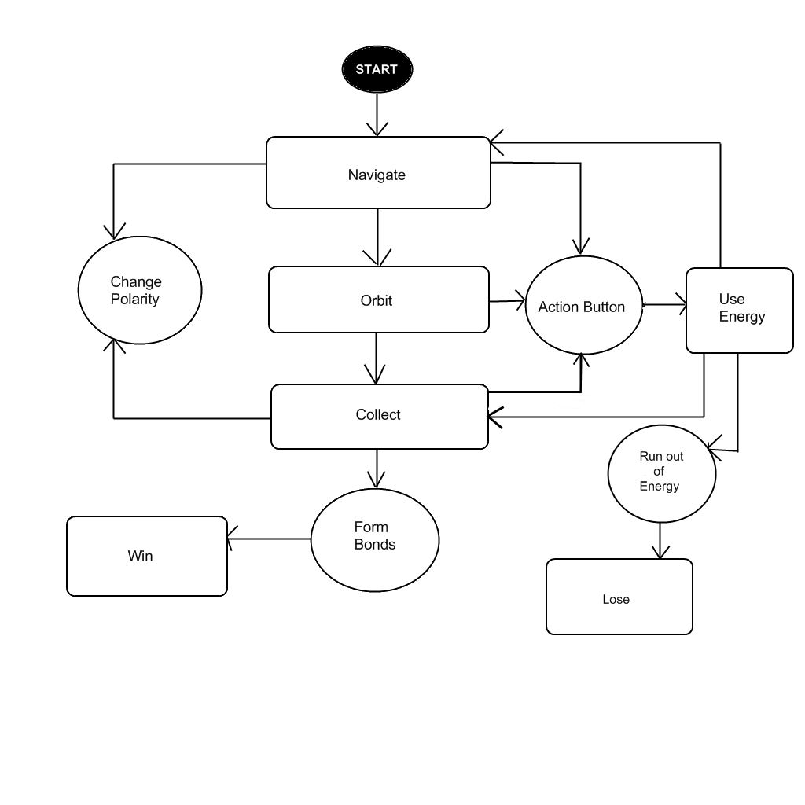
Glossary of Terms

Atom – Objects floating in the world that will cause gravitational pulls on Quark. Each atom will be the color red, green, or blue to represent its polarity.

Bond – A link created between atoms when the correct balance of elections has been achieved.

Builder – A mode of game play where the objective is to create a molecule using a designated number of each colored atom.

Collect – Use the action button to absorb electrons of the chosen polarity. This can only be done in the Collection State.

Collection State – While in this state, the player changes Quark’s polarity to collect or drop-off electrons. The player may only collect or drop-off electrons that match the current color of the polarity. While in this state, the polarity has no effect on the atoms. The player may only enter this state after being locked in Orbit.

Drop Off – Use the neutral button to release electrons of the chosen polarity. This can only be done while in the Collection State.

Dark Matter – A hazard that, when passed through, will drain the player’s energy at the rate of 5% per second.

Electron – Small spheres that the player must move from atom to atom in order to create a bond. Electrons will circle around atoms and will be colored red, green, or blue.

Energy – This is the player’s power source. Using the action button will drain the Quark’s energy. If the player runs out of energy the game is over.

Energy Boost – A power-up that restores some of the player’s total energy.

Molecule – A collection of atoms that have been bonded together.

Move – Use polarity to gravitate toward other atoms. If the player is in orbit, changing the polarity to any color other than the current one will cause them to detach and move to the nearest atom of that color.
Navigation State – While in this state, the player changes Quark’s polarity to affect the pull towards different atoms. During this time, the player will be pulled towards atoms that match the color of the current polarity. While in this state, the polarity has no affect on the electrons.

Neutrality – Quark has no polarity is not affected by any gravitational pulls and continues to move in his current direction.

Orbit – When the player approaches an atom at the proper speed they will begin to orbit the atom. When this occurs, the player will not be affected by the pull of any other atoms.

Polarity – Polarity is the gravitational pull between Quark and the various atoms and electrons. It is used for movement, collection, and drop-offs.

Polarity Wheel – This is the graphical representation of the player’s current polarity. On the HUD there will be a circle split into three sections: red, green, and blue. In the wheel there will be a needle that points to the current polarity and rotates as the player changes the polarity.

Quark – This is the main “character” of the game that the player takes control of. Quark will be made of several spheres mashed together and will take on the color of the current polarity.

Slingshot – An action that causes the player to increase their orbit speed around an atom. An arrow will appear to show how fast and in what direction the player will travel.

Slingshot Arrow – A visual representation of the speed and direction that player will travel in when performing a Slingshot.

Time Attack – A mode of game play that requires the player to complete a Builder in a set amount of time.

Characters

Name/ID
Quark

Brief Description
Quark is the representation of the player inside of the game world. He is whom the player uses to perform all of the actions required to build molecules and complete the game’s goals.

Visual Design
Quark is a blob like entity. He is a collection of three spheres of green, blue, and red, that mold and combine with each other in a semi-random fashion. He has a faint glow of the color his certain polarity is set to. When he is neutral or inactive, he will have no glow emanating from him.

Behaviors
- Move
- Orbit
  - Collect
  - Drop Off
  - Slingshot

Attributes
- States
  - Navigation
  - Collection
  - Orbit
  - Neutral
- Collection/Drop Off Rate
  - 1 electron per second
- Max Electrons
  - 8
- Current Electrons
- Normal Speed
  - Navigation
    - Max 5 units per second
  - Orbit
    - 10 units per second

Name/ID
Atom

Brief Description
Atoms are the objects in the world that the player is trying to create bonds between. They will each have their own polarity and gravitational force that affect the way the player can move.

Visual Design
Each Atom can be red, green, or blue. This will affect what color Quark’s polarity needs to be in order to be attracted to that particular Atom. They will all have a glow effect that matches the color of their polarity, and the body of the Atom is a swirl of different shades of that color.

Attributes
- Polarity
  - Red
  - Green
  - Blue
- Diameter
  - 7-10 units
- Weight
  - 700-1000 units
- Max Electrons
  - 8
- Current Red Electrons
- Current Green Electrons
- Current Blue Electrons
- Max Bonds
  - 4
- Current Bonds
Red and Green Atoms

Blue Atom
Power-ups

Collision
- When the player collides with a power-up, a sound will be played and the player will gain the effect of the power-up.
- The power-up will move towards the player and absorb into the player when they come close enough.

Name/ID
Energy Boost

Brief Description
This restores a quarter of the player’s energy bar, allowing the player to perform more actions without running out of energy.

Visual Design
The Energy power-up will be the same size as all other power-ups, and appear and as a shiny translucent orb. Inside this orb there will be a bright red pulsating and glowing effect.

Attributes
- Effect amount
  - 25% of player’s total energy
- Collection radius
  - 5 units

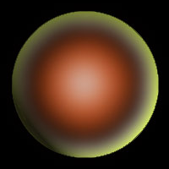

Levels and Maps

Level Travel
The main character moves around the world by gravitating to different atoms by changing their polarity. See the character information section for specific abilities and attributes.

Level Walkthroughs
Since Particle Panic is a puzzle game, the player can solve each level in more than one way. Level Walkthroughs in this document provide a possible solution to each level, but the player is not limited to doing it the specified way.

Scale
- Quark – 2.5 unit diameter
- Atoms – 10 unit diameter
- Electrons – .75 unit diameter
- Bonds – 3 unit diameter, 10 unit length
- Dark Matter – no set size
- Power-ups – 4-5 unit diameter
- Level Bound – 20 cubic units per atom

Environmental Interactions - Behaviors
- Bond forming
  - Bonds are formed by equalizing electron counts between two different atoms, and are required to advance through the level.
  - If a bond is formed through Dark Matter, the Dark Matter will be destroyed.
- Wall collision
  - If Quark collides with any of the level’s boundaries, he will bounce back and the wall will light up.
  - Atoms and power-ups will simply bounce off.

Ambient Environmental Aspects/Objects in the Level
- Particle effects
  - Collision between two atoms
  - Collision between Quark and atoms
  - Bond effects
  - Electron collection/release
  - Slingshot tail effect
- Sound effects
  - Collision between two atoms
  - Collision between Quark and atoms
  - Bond formation/destruction
  - Electron collection/release
  - Slingshot charging/release
  - Collision between Quark and walls
  - Collision between atoms and walls
- Background music
- Background visual

Name/ID
Tutorial 1

Goal
Make a molecule consisting of a red and a blue atom.

Attributes
- Atoms – 3
  - 1 red, 1 green, 1 blue
- Electrons – 6
  - 2 per particle

Time
Average play time: 5 minutes

Map
.
Level Walkthrough – Verbal Map
- Navigate towards blue atom
  - Absorb both blue electrons
- Navigate towards red atom
  - Absorb both red electrons
  - Drop off both blue electrons
- Navigate back to blue atom
  - Drop off both red atoms
Name/ID
Tutorial 2

Goal
Make a molecule consisting of a red, blue, and a green atom.

Attributes
- Atoms – 3
  - 1 red, 1 green, 1 blue
- Electrons – 8
  - 2 blue, 2 red, 4 green
Time
Average play time: 3 minutes
Time Attack Mode: 2 minutes

Map
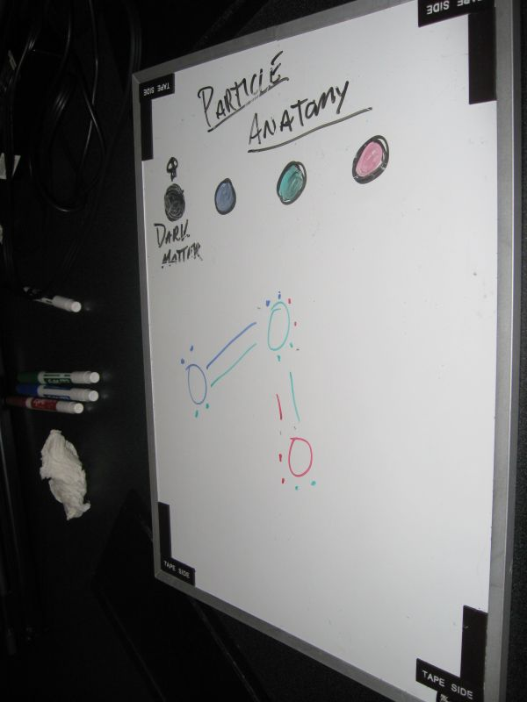

Level Walkthrough – Verbal Map
- Navigate towards blue atom
  - Absorb all two blue electrons
- Navigate towards green atom
  - Absorb both green electrons
  - Drop off two blue electrons
- Navigate back to blue atom
  - Drop off both green atoms
- Navigate to red atom
  - Drop off two green electrons
  - Absorb two red electrons
- Navigate back to green
  - Drop off two red electrons
Interactive System

In Particle Panic the player has two main ways of interacting with the world and solving puzzles. The first is using the polarity attributes to navigate the world, the second allows the player to collect and drop off electrons. Electrons are the main “currency” of the game. When and equilibrium of electrons is created between two atoms i.e. a Red atom has one red electron and one blue electron and a Blue atom has one red and one blue electron, a bond is formed. The player must form bonds to complete the level specific goal, whether it is a Time Attack or Builder mode. The player has an Action button and a Neutral button to perform abilities in both modes. Holding down the action button in either mode depletes a certain amount of energy from the player’s energy bar for the time held. The player is also able to change the camera perspective at anytime in the game. By using the joystick/mouse the player can move the rotate the camera around the player in the 3rd person perspective. There will also be a button that zooms out so the player can view the entire map. They will have the ability to rotate the camera around to see different angles of the world.

Polarity Movement (Free Roaming)
- Player moves through the world by manipulating polarity attributes.
- Polarity Wheel shows the player their current polarity (see Interface).
- Player gravitates toward the nearest atom of that polarity.
- Holding down the Action button makes the player gravitate faster towards an atom.
- Holding down the Neutral button “neutralizes” the polarity.
  - Grays out the polarity wheel
  - No gravitational force will affect player
  - Current momentum is conserved
  - Player will begin to slow down
- To orbit an atom:
  - Player must be in close proximity of the atom
  - Player must maintain proximity for a short amount of time
  - Player’s speed must not exceed a certain amount

Orbital State
- Camera focuses on atom the player is orbiting.
- Player has the ability to collect electrons from that atom.
  - Switching to Collect mode does not break orbit
  - Player can either drop off or absorb electrons
- Player has the ability to Slingshot
  - Hold down the Action button to Slingshot
  - Release Action button to cancel Slingshot
  - Hollowed arrow appears in direction camera is facing
  - Arrow fills up as player continues to charge
  - The more the charge the faster the player will be ejected in the direction of the arrow
  - Pressing the Neutral button shoots the in the direction of the arrow
  - Player can use the camera to change direction of the arrow
- Player can leave orbit by holding the Neutral button.

Collection System
- Player can carry up to eight electrons at a time.
- Player can only collect or drop off electrons while orbiting.
- Player only absorbs or deposits electrons of his current polarity.
- Player must hold down Action button to absorb electrons
  - Consumes significantly less energy than navigation mode
  - Sucks electrons toward the player at a consistent rate
  - When released electrons stop gravitating toward player
- Player can hold the Neutral button to deposit atoms
  - Releases electrons at a consistent rate
  - Only releases electrons of the current polarity

Special Abilities

Slingshot Mode

- Only available while player is orbiting an atom
- The Slingshot Arrow will appear and point in the direction the camera is facing
- Camera will zoom out slightly for better view
- Holding down the Action button charges your shot
  - Arrow begins to fill up
  - Arrow represents the speed and direction of shot
  - Releasing the Action button cancels the shot
  - Hitting the Neutral button launches the player
- Energy bar will be drained according to power of the shot
  - No energy deducted for canceling

Game Logic, Algorithms, and Rules

Interaction Component Matrix

See the accompanying Excel sheet for the full Interaction Component Matrix.

Key Game Algorithms

Gravitational Acceleration

float Acceleration_Gravity (Object object1, Object object2)
{
Return GravitationalConstant * object2.mass / (DistanceBetweenObjects)squared
}

Player State Contextual Switch

switch (player.GetState())
{
case NAVIGATE_STATE:
{
if (player.forwardMomentum < nearestAtom.gravitationalPull)
player.SetState(ORBIT_STATE);
}
case ORBIT_STATE:
{
if (player.forwardMomentum > nearestAtom.gravitationalPull)
player.SetState(NAVIGATE_STATE);
}
}

Check for Possible Bonds

if (player just switched out of collection mode…)
{
for (int i = 0; i < nearestAtom.electrons.size(); ++i)
{
if (i + 1 % 2 == 0)
{
switch (nearestAtom.electrons [i].type)
{
case RED:
{
for (int j = 0; j < redAtoms.size(); ++j)
redAtoms[j].CheckElectrons(i, RED);
}
case GREEN:
{
for (int j = 0; j < greenAtomList.size(); ++j)
greenAtoms [j].CheckElectrons(i, GRN);
}
case BLUE:
{
for (int j = 0; j < blueAtomList.size(); ++j)
blueAtoms [j].CheckElectrons(i, BLUE);
}
}
}
}
}

bool Atom::CheckElectrons(int num, int type)
{
switch (type)
{
case RED:
{
if (redElectrons.size() == num)
return true;
}
case GREEN:
{
if (greenElectrons.size() == num)
return true;
}
case BLUE:
{
if (blueElectrons.size() == num)
return true;
}
}

return false;
}
FAQ

- What is Particle Panic?
  - Particle Panic is 3-d puzzle game in which the player uses gravitational forces to move around the world and create bonds between different atoms to create a target molecule.
- How do you move around the world?
  - Navigation in the game is accomplished by giving the main character a polarity, which will make him attract to the atoms that match that polarity.
- How do you create a bond?
  - Bonds are created by creating electron equilibrium between 2 atoms. This is accomplished by transferring collecting and dropping off electrons to and from atoms.
- How do you collect and drop off electrons?
  - When the player is orbiting an atom, they may then enter collection mode. Then, they can select the polarity of the type of electron they would like to collect, and hold down the Action button to absorb them.
- How do you orbit an atom?
  - If the player comes close enough to an atom and his forward momentum is less than the gravitational pull of that atom, he will be sucked into it and enter an orbit around the atom.
- How do you enter collection mode?
  - The player will be able to toggle between collection mode and navigation mode by holding down a polarity. The player can only enter collection mode when orbiting an atom.
- What is the Energy Boost power-up?
  - The Energy Boost power-up will restore a certain amount of the player’s energy bar.
- What is Dark Matter?
  - Dark Matter is the “enemy” of the game. It can spawn randomly in some levels, and when passed through, will drain the player’s energy.
- What is Energy?
  - Energy is the player’s “health”. It is used up when the player performs actions, or if he passes through Dark Matter. Energy is replenished when the player makes a bond, or picks up an Energy Boost power-up.
- How does the player perform actions?
  - The Action Button will perform all of the actions in the game. These include collecting and releasing electrons.
- How and why does the player go Neutral?
  - The player can go Neutral at any time by pressing the Neutral button, which will essentially deselect their polarity. This will cause them to have no attraction to any particle, thus making them travel in their last direction.
- What is the target audience of this game?
  - This game will be target towards the casual gamer audience, such as the Xbox Live Arcade or Pop Cap Games demographic.
- What type of physics system will you use?
  - Particle Panic will use a state based Newtonian physics system that will be able to seamlessly transition between a free-roaming movement and navigation mode and an orbital mode used for performing actions.
- When will the bonds actually be formed and broken?
  - When the player drops off or picks up an electron, the system will check for all possible bonds and will then create or destroy them accordingly.
Reference of Key Elements

Scoring

The player typically advances through the game by successfully completing the molecule that was specified as the goal for that particular level. There is no specific scoring system based around this goal, just whether or not the player has completed it or not.
However, the player does have energy, which could be considered his health. This energy is reduced by using the action button, depending upon the activity, and the player loses when their energy reaches zero. Energy can be restored by creating bonds, or by picking up power-ups.

Winning/Losing

The player wins a level by successfully completing the associated goal or goals for that level. These could include creating a specific molecule in Builder mode, where the player must make specific bonds between atoms, or a Time Attack mode, where either of the previous two modes could be used with the addition of a time limit.
During the campaign mode, the player wins the game when all of the levels have been successfully completed in order. The player can lose mainly by running out of energy on any given level, or if they run out of time on the time-attack mode.

Transitions

The player’s progress will only be saved during the campaign mode, where upon successful completion of each level, their current completion state will be written to disk. This system will involve the use of profiles, where more than one player can have their own save point for a campaign.
There will not be any specific load feature for the game, the player only has to enter the campaign screen and select the most recent level that they have unlocked to continue. Also, each level will give the player the option to restart the current level from the beginning.
Art and Production Design

3D Art & Animation Deliverables

All 3D art should be in .x file format

- Atoms
- Electrons
- Quark
- Bonds
- Dark Matter
- Power-Ups
- World Bounds
- Menu Items
- Slingshot Arrow

2D Art (HUD/Menu/Particle/Textures) Deliverables

All 2D art should be in .dds file format (DXT5 compression)

- Fonts
- Menu Items
- Atoms
  - Electricity effects
  - Bond effects
  - Action effects
- HUD Items
  - Polarity wheel
  - Energy bar
  - Particle/Electron indicators
- Background
- Textures
  - Atoms
  - Electrons
  - Quark
  - Dark Matter

Sound Effects Deliverables

All sound files should be in .wav file format

- Atoms
  - Collision
    - Quark
    - Atoms
- Electrons
  - Collection
  - Release
  - Ambience
- Bonds
  - Creation
  - Destruction
  - Ambience
  - Collision
- Quark
  - Neutral
  - Collision
    - Walls
  - Energy usage
  - Low energy
- Power-ups
  - Ambience
  - Collect
  - Effect
    - Invulnerability
    - Energy Boost
    - Unlimited Energy
- Menu
  - Select
  - Back
  - Change screen
- Level Complete
- Level Failed
- Time low

Music Deliverables

All music should be in .wav file format

- Menu
- Game
  - Builder
  - Time Attack

Coding Standards

Naming Standards
- The name of every variable or class must describe what it represents, but also remain small enough to not overwhelm the code base.
  - Good: class ObjectManager
  - Bad: class ThingThatContainsAndUpdatesObjects
- All names will use the “Camel Caps” methodology of capitalization, with the exception of prefixes.
  - int nCamelCaps

Prefix Convention
One character maximum prefix for every member variable. If a member variable is a data structure of a certain data type, the name should reflect that i.e m_fColorArray.
- m_ must precede every member variable and comes before any other prefixes.
  - int m_nMemberVariable
- c must precede every char.
  - char cExampleChar
- n must precede every int.
  - int nExampleInteger
- f must precede every float.
  - float fExampleFloat
- s must precede every short.
  - short sExampleShort
- p must precede every pointer.
  - void *pExamplePointer
- sz must precede every string.
  - String szExampleString
  - char *szExampleString
- u must precede every unsigned variable.
  - unsigned int unExampleUnsignedInt
  - unsigned char ucExampleUnsignedChar

Classes
- The member variable naming conventions for classes will be the same as structures.
- All classes must have a constructor and destructor.
  - Any dynamic memory created inside the class must be cleaned up by the destructor.
- Copy constructors and assignments are optional, and should only be used when necessary.

Relevant Function Names
- Function names follow the same conventions as variables, except that functions have no prefixes.

Macros and Constants
- #defines are required over global constants, but only used when absolutely necessary.
- #defines will always be declared that the top of the file, directly after all #includes and namespaces.
- C-style macros are permitted, but only if absolutely necessary.
- C-style macros will always be placed directly under #defines.

Commenting
- .h files will have a comment at the top, above all other code.
- File comment block for .h only:
  - // Author: Name
- .cpp files will not require a comment block.
- Functions will have a comment block above their declaration, only in the .h file.
- Function comment block for function declaration only:
  - // Params: Short description of parameter 1.
  - // Short description of parameter 2.
  - // Short description of parameter n.
  - // Return: Short description of what the return value is/does.
- Function definitions will not require a comment block.
- All other generic commenting is not required, but strongly recommended on ambiguous or non-common code.

Data Alignment
- Data alignment is not required.
Coding Guidelines
- All singletons must follow the definition as stated in Design Patterns, p. 129.
  - In addition to the constructor, the copy constructor, assignment operator, and destructor must all be declared and put in the protected section, however, only the constructor and destructor must be implemented.
- Static memory should be used as much as possible over dynamic memory.
  - Any dynamic memory that has to be used must not be allocated during runtime of the game.
  - Each class is responsible for cleaning up its own dynamic memory, should it be needed, in the destructor.
- Pointers will be used instead of references.
  - Any variable over 4 bytes in size that needs to be passed to a function should be passed by pointer.
- Classes must use accessors and modifiers to manipulate their internal data, and should be inlined.
- The MainGame class will hold all Windows specific and game data specific globals that need to be accessed.
Development Environment

Compiler
- Visual Studio C++ 2005

API
- DirectX 9.0c (November 2007)
  - Direct3D
  - XInput
  - DirectSound

Shader Compiler
- RenderMonkey 1.8
- FX Composer 2.0

Art Assets
- 3D art
  - Maya
- 2D art
  - Adobe Photoshop Elements 4.0
  - Adobe Photoshop CS 3.0
  - Open Canvas 1.71b

Source Control
- Alienbrain 7.5

Timing Specifications

- Target frame rate: 60 fps
- Frame computation breakdown (1/60th of a second)
  - Input: 2%
  - Physics: 15%
    - Movement: 5%
    - Collision: 10%
  - Particles: 8%
    - Updating: 4%
    - Rendering: 4%
  - Game logic: 5%
  - Rendering: 70%
    - Scene Culling: 20%
    - Scene Sorting: 10%
    - Context Switching: 30%
    - RenderFunc (Object draw calls): 10%

System Architecture

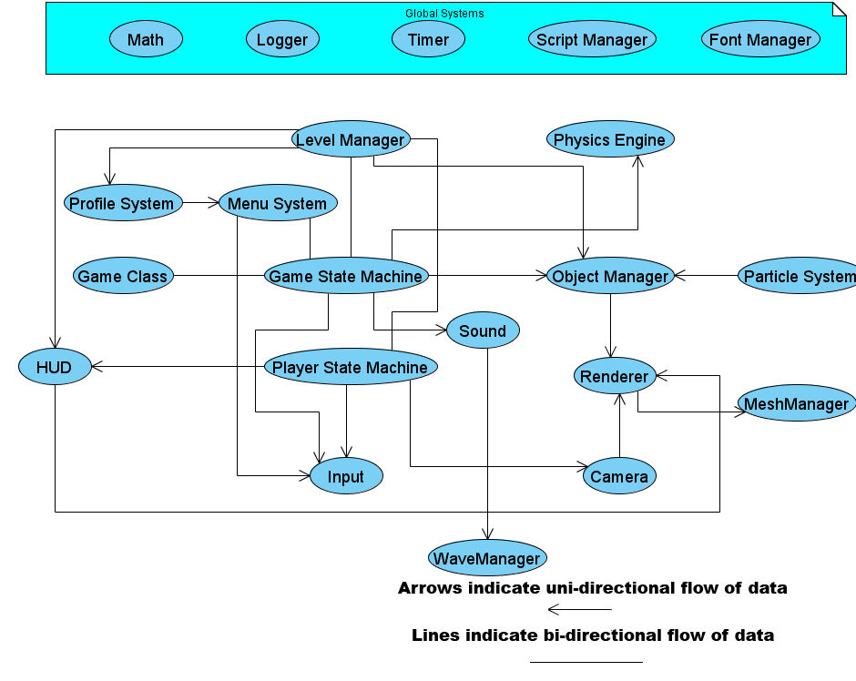
Context Model Description

Renderer
- Object Manager
  - Passes all objects to be rendered
- Camera
  - Gives the Renderer its view matrix
- HUD
  - Tells the Renderer what to draw

Texture Manager
- Level Manager
  - Add textures associated with a level and its objects
- HUD
  - Add textures used for HUD information
- Renderer
  - Uses the Direct3D device to load the textures into memory

Shader Manager
- Level Manager
  - Add shaders associated with a level and its objects
- Renderer
  - Uses the Direct3D device to load the shaders into memory

Mesh Manager
- Level Manager
  - Add meshes associated with a level and its objects
- Renderer
  - Uses the Direct3D device to load the meshes into memory

Input Manager
- Player State Machine
  - Receives info and updates according to input
- Game State Machine
  - Receives input and handles it accordingly
- Menu System
  - Receives info and updates according to input

Physics Engine
- Object Manager
  - Objects are passed between the Physics Engine and Object Manger

HUD
- Player State Machine
  - Tells the HUD player info
- Level
  - Gives HUD level progression info
- Renderer
  - Receives HUD data to draw

Camera
- Player State Machine
  - Rotate the camera based on input
- Renderer
  - Passes data used to build the frustum

Script Manager
- Global access

Menu System
- Profile System
  - Tells what profile to load based upon menu selection
- Input
  - Allows the user to select menu items
- Game State Machine
  - Changes the game state machine’s internal state based on user selection

Object Manager
- Timer
  - Gets the game’s current time slice
- Physics Engine
  - Sends all objects to the physics simulation
- Renderer
  - Sends all objects to be drawn
- Sound Engine
  - Plays sounds based on object interaction
- Game State Machine
  - Base functionality called, such as update
- Level Manager
  - Loads level data

Game State Machine
- Level Manager
  - Tells Game State when the player has completed the goal
  - Is notified of player state updates
- Object Manager
  - Is called to update all objects in the Game State loop
- Sound Engine
  - Tells the sound engine to play the game mode’s music
- Player State Machine
  - Relays state changes
- Menu System
  - Tells Game State what level to load
  - Is manipulated like an object by Game State
- Game Class
  - Data transferred during initialization and shutdown of modules
  - Access to global variables

Player State Machine
- Input
  - Gathers input from the player through the player’s state
- Camera
  - Receives info on the player’s state

Level Manager
- Game State Machine
  - Tells Game State level update logic
  - Receives player info from the Game State
- Profile System
  - Tells the profile system what has been completed
- HUD
  - Gives HUD level progression data
  - Profile System
  - Informs profile system of achievements made
- Script Manager
  - Uses scripts to load levels
- Object Manager
  - Gives Object manager all level objects

Font Manager
- Renderer
  - Used to draw the font textures
- Global access

Sound Engine
- Object Manager
  - Tells Sound Manager when to play sounds
- Game State Machine
  - Tells Sound Manager when to play music
Wave Manager
- Level Manager
  - Add sounds associated with a level to memory
- Game State Machine
  - Add music associated with the game type
- Sound Engine
  - Uses the DirectSound object to load wave files into memory

Particle System
- Object Manager
  - Sends Emitter data as an object to be managed and rendered

Profile System
- Menu System
  - Accesses player profile data to display
System Feature Breakdown

Renderer
This module is responsible for drawing all of the game’s content to the screen. It also contains functionality for frustum culling and scene management. All of the game’s objects that wish to be rendered need to be derived from RenderNode, which provides base functionality for culling, texturing, positioning and orientation, mesh information, and shader functionality. The renderer then uses its internal RenderFunc function pointer, which is set up by the user, to draw the object. This enables custom render functions to be used for special objects, while keeping the renderer modular.

Render System Hierarchy
- RenderNode is the base class all objects should derive from
  - Contains the object’s world matrix
  - Contains a RenderFunc function pointer
    - Used to assign custom render functions written independently of the renderer to allow extended functionality
    - Format: void YourRenderFuncName(RenderNode *this)
    - Function must be static, so RenderNode * acts as “this”
  - Holds a pointer to a RenderContext and a RenderShape
    - RenderContext
      - Contains appearance related code, such as color, shaders, textures
    - RenderShape
      - Contains model related code, such as the mesh and its bounding sphere, used for scene culling
    - These can be filled out, assigned, and then accessed inside of the render function through the RenderNode *

Dependencies
- Access by the following
  - Object Manager
    - Sends a list of render nodes to be rendered.
  - Camera
    - Sends information to build the frustum.
  - HUD
    - Sends texture info and positions.

Features
- Frustum culling
  - Builds a frustum based upon input gathered from a camera class.
- Scene management
  - Sorts all of the objects in the render scene by context, and eventually, draw order based upon transparency.

Methods
Return Type | Function Name | Parameters | Description
void | BuildFrustum | Matrix *pView  float fFOV  float fNearClip  float fFarClip | Takes in all the data from the Camera class used to build a frustum.
void | Render | std::vector *pNodes | Takes in a list of Render Nodes, sorts them, and calls their Render Functions.
void | Initialize | HWND hWnd | Creates and initializes the Direct3D object and device, and sets up basic render functionality.
void | Shutdown | void | Releases all Direct3D objects.

Estimated Time to Complete
Renderer – 20 days
- Basic implementation – 5 days
  - Render node class – 1 day
  - Appearance class – 1 day
  - Direct3D interface – 3 days
- Frustum culling – 3 days
- Depth sorting – 3 days
- Alpha blending – 5 days
- Testing – 3 days
- Integration – 1 day

Module Author(s)
- Michael Tomasino

Texture Manager
This module is responsible for loading textures and storing them to be used during the game. When a texture is loaded, a unique handle is returned to the invoking object which can be used to access the stored texture at a later time.

Dependencies
- Access by the following
  - Level Manager
    - Add textures associated with a level and its objects.
  - HUD
    - Add textures used for HUD information.
- Access to the following
  - Renderer
    - Uses the Direct3D device to load the textures into memory.

Features
- Loading Textures
  - Loads textures from files and assigns them a unique ID.

Methods
Return Type | Function Name | Parameters | Description
int | LoadTextureFromFile | char *szFile | Loads a texture from a file and gives back a unique ID for access to it.
void | RemoveTextureFromList | int nTexID | Unloads a texture from the manager.

Estimated Time to Complete
Texture Manager – 4 days
- Basic implementation – 1 day
- File I/O – 1 day
- Testing – 1 day
- Integration – 1 day

Module Author(s)
- Michael Tomasino
Shader Manager
This module is responsible for loading shaders and storing them to be used during the game. When a shader is loaded, a unique handle is returned to the invoking object which can be used to access the stored shader at a later time.

Dependencies
- Access by the following
  - Level Manager
    - Add shaders associated with a level and its objects.
- Access to the following
  - Renderer
    - Uses the Direct3D device to load the shaders into memory.

Features
- Loading Shaders
  - Loads shaders from files and assigns them a unique ID.

Methods
Return Type | Function Name | Parameters | Description
int | LoadShaderFromFile | char *szFile | Loads a shader from a file and gives back a unique ID for access to it.
void | RemoveShaderFromList | int nShaderID | Unloads a shader from the manager.

Estimated Time to Complete
Shader Manager – 7 days
- Basic implementation – 1 day
- File I/O – 1 day
- Testing – 1 day
- Integration – 3 days

Module Author(s)
- Michael Tomasino
Mesh Manager
This module is responsible for loading meshes and storing them to be used during the game. When a mesh is loaded, a unique handle is returned to the invoking object which can be used to access the stored mesh at a later time.

Dependencies
- Access by the following
  - Level Manager
    - Add meshes associated with a level and its objects.
- Access to the following
  - Renderer
    - Uses the Direct3D device to load the meshes into memory.

Features
- Loading .x Files
  - Loads meshes from .x files and assigns them a unique ID.

Methods
Return Type | Function Name | Parameters | Description
int | LoadMeshFromFile | char *szFile | Loads a mesh from a file and gives back a unique ID for access to it.
void | RemoveMeshFromList | int nShaderID | Unloads a mesh from the manager.

Estimated Time to Complete
Mesh Manager – 4 days
- Basic implementation – 1 day
- File I/O – 1 day
- Testing – 1 day
- Integration – 1 day

Module Author(s)
- Michael Tomasino
Input Manager
This module is responsible for querying or polling the current connected or selected input device. It will save that device’s state every frame. The controls of the game will be abstracted out into actions that the player can perform i.e. Action button, Neutral button, Joystick rotation. This allows for the controls to be mapped to whatever the user wishes based on the input device. For handling the two main types of input, the Input Manager will maintain its own internal state.
There will be two main API’s that the Input Manager will need to encapsulate: DirectInput and XInput. The user will be able to control the game using both the mouse and keyboard or the Xbox360 controller.

Dependencies
- Accessed by the following
  - Player’s State machine
  - Game State machine
  - Menu System
Features
- Reads input from current device
  - XInput – Xbox360 controller
  - DirectInput – keyboard/mouse
- Allows the user to map their own specific controls to actions
- Stalls game loop if a device is lost (controller disconnected)
- Input Object
  - An abstraction of the current device holding a snapshot of that device’s states every frame.

Associated Risks
Risk: | Affected Resource: | P | C | RF
Integration with Menu System might be more involved and difficult when mapping controls | Andrew Zeck | .5 | .4 | .7
 | Response or avoidance:
-Create a special game state that handles input in the Menu System differently
-Abstract controls into actions
-If not done by Alpha, drop it and just stick with default controls

Risk: | Affected Resource: | P | C | RF
Pressure sensitivity in joystick triggers maybe difficult to correlate to game actions | Andrew Zeck | .4 | .3 | .58
 | Response or avoidance:
-Allow other modules to create their own methods of dealing with the values
-Use a logarithmic function with time pressed to create a constant value representing button pressure

Risk: | Affected Resource: | P | C | RF
Mouse movement will be differ from the way the joystick manipulates the camera | Andrew Zeck | .4 | .3 | .58
 | Response or avoidance:
-Allow other modules to create their own methods of dealing with the values
-Use a logarithmic function with time pressed to create a constant value representing button pressure

Methods
Return Type | Function Name | Parameters | Description
Void | Initialize | Void | Sets up DirectInput and Xinput, determines what state to enter based on devices connected
Void | SwitchDevice | Void | Switches the current device context from joystick to keyboard or vice versa
Void | GetDeviceState | Void | Gets the current input device’s state and stores it internally
Void | GetCameraStick | float &, float & | Pass in two floats to get the current X and Y rotation of the Camera ( values range from -1.0 to 1.0)
Void | GetPolarity | float&, float&, float& | Gets the current polarity based on user input
float | GetAction | Void | Returns a float based on pressure of the button
bool | GetBufferedAction | void | Gets the Action key buffered
float | GetNeutral | Void | Returns a float based on pressure of the button
bool | TogglePlayerState | Void | Returns a bool if the toggle player state button was pressed
bool | ToggleCameraState | Void | Returns a bool if the toggle camera state button was pressed
Void | GetMouse | int&, int& | Returns a mouse position
bool | GetSelect | Void | Returns a bool if the select button was pressed
bool | GetPause | Void | Returns a bool if the pause button was pressed
Void | SetJoystickConfig | enum | Maps the joystick configuration to one of the control schemes
Void | SetActionKey | Void | Waits for the player to enter a key, then maps it to the action button
Void | SetNeutralKey | Void | Waits for the player to enter a key, then maps it to the neutral button
Void | SetToggleCameraKey | Void | Waits for the player to enter a key, then maps it to the toggle camera key
Void | SetTogglePlayerStateKey | Void | Waits for the player to enter a key, then maps it to the toggle player state key
bool | GetKeyAction | enum | Takes in an enum for a specific game action, this function is for flexible key mapping
bool | GetBufferedKeyAction | enum | Same as the function above, only buffered

Estimated Time to Complete
Input Manager – 8 days
- Basic Implementation – 1 day
- XInput – 1 day
- DirectInput – 2 days
  - Mouse/Camera rotations – 1 day
  - Key Mapping – 2 day
- Testing – 3 days
  - Polarity Manipulation – 2 days
  - Smooth Camera Rotation – 1 day
- Integration - 1 day

Module Author(s)
Andrew Zeck
Physics Engine
This module is responsible for running the physics simulation on all of the objects in the game. It will calculate positions using the Velocity Varlet Method of Integration and collision will make use of Sphere to Sphere and Sphere to Plane algorithms. Game objects will have a pointer to a PhysicsNode, which contains all of the data used for physical movement, such as mass, velocity, and force. It also contains a function pointer used for the collision callback functionality, so the user can handle collisions outside of the engine.

Dependencies
- Access by the following
  - Object Manager
    - Sends all of the objects in the game to be run through the physics simulation.
- Access to the following
  - Object Manager
    - Utilizes a callback function to tell each object in the manager who has collided with whom.

Features
- Gravitational Movement
  - Moves all of the objects in the game realistically, based upon gravitational forces and “pulls”.
- Collision Detection
  - Determines if any two objects are colliding, and then calls their associated function, telling the rest of the system that the two primitives have made contact.

Associated Risks
Risk: | Affected Resource: | P | C | RF
Implementing a full Physics Engine with Collision Callbacks used as collision feedback, as opposed to the simpler method of incorporating collision into the Object Manager, where each object can get immediate feedback on what collisions have occurred. | Mike – Physics Engine | .3 | .5 | .65
 | Response or avoidance:
- Research the use of a collision callback system.
- Ask Bahin/Shawn after POC if still not sure.
- Remove separate engine and incorporate collision and movement into the object manager and individual objects by FF1.

Methods
Return Type | Function Name | Parameters | Description
void | Update | float | Computes physics and collision for the list of bodies.
int | AddBody | PhysicsNode * | Adds a body to the simulator and returns an ID to it.
void | RemoveBody | int | Removes the specified body from the system.
void | ClearBodies | void | Clears all bodies from the system.
void | Initialize | void | General setup for the engine.
void | Shutdown | void | General teardown for the engine.

Estimated Time to Complete
Physics Engine – 16 days
- Basic implementation – 4 days
  - Physics node class – 1 day
  - Collision call back system – 3 days
- Collision – 3 days
  - Sphere to Sphere – 1 day
  - Plane to Sphere – 1 day
  - Cylinder to sphere – 1 day
- Movement – 5 days
  - Basic velocity – 1 day
  - Gravitational – 4 days
- Testing – 3 days
- Integration – 1 day

Module Author
- Michael Tomasino
Camera
The camera module will be responsible for maintaining a 3rd person perspective of the game world. It will have several states that allow the player to view the world from various 3rd person perspectives. These include following the player, focused on the atom the player is orbiting, and focused on the entire world map. The camera depends on knowing what state the player is in, and what input has been made so it can adjust accordingly. Normally, it will follow the player at a certain distance based on the player’s velocity. It will only be able to rotate on the two fixed X and Y axis around its focus. It will ultimately be responsible for maintaining its orientation so that a view matrix can be constructed from it by the graphics engine.
Extra added features will include a fly-by system. This will contain queue of “key-frames” which will hold a position, rotation, and time. The camera will initiate a fly-by sequence by interpolating between these key-frames according to a provided time step.

Dependencies
- Access to the following
  - Renderer
- Access by the following
  - Player State Machine
  - Menu System

Features
- Accsessor functions for modifying its internal orientation matrix.
- Orbital behavior around its “focus”
  - PLAYER – 3rd person following state
  - ORBIT – Focused on the atom the player is orbiting
  - WORLD – Allows the player to view the entire map
- Fly-by sequence loaded from a script
- Construct a view matrix for the renderer
- Smooth rotations/zooming
- Velocity based following

Associated Risks
Risk: | Affected Resource: | P | C | RF
3rd person perspective may cause usability issues for the player because the gameplay is unique and untested | Andrew Zeck, camera | .5 | .7 | .85
 | Response or avoidance:
 | -Have a fixed 3rd person perspective of the game world and allow player to zoom and rotate

Methods
Return Type | Function Name | Parameters | Description
Void | Initialize | vector WorldUp, vector LookAt | Takes in floats to construct a orientation matrix
Void | GetForward | vector & | Accessor
Void | SetForward | vector | Mutator
Void | GetPosition | vector& | Mutator
Void | SetPosition | vector | Simple mutator
Void | SetState | enum | Sets the camera’s current state : PLAYER, ORBIT, WORLD
GameObject* | GetFocus | void | Accesor
Void | SetFocus | GameObject* | Set’s the camera’s current focus (performs a look at algorithm at the target’s position)
enum | GetState | Void | Returns the camara’s current state
Void | RotateCameraX | float | Rotates the camera on its X axis
Void | RotateCameraY | float | Rotates the camera on its Y axis
Void | RotateCameraWorldX | float | Rotates the camera on the world X axis
Void | RotateCameraWorldY | float | Rotates the camera on the world Y axis
Void | ZoomIn | float | Zooms the camera in a certain distance (WORLD state only)
Void | ZoomOut | float | Zooms the camera out a certain distance (WORLD state only)
Void | LoadFlyBy | char* | Takes in a filename and uses the Script Manager to load in a fly-by sequence
Void | Update | float | Takes in the current timeslice, updates the camera accordingly based on its state, normalizes the camera’s orientation matrix, and finally tells the Renderer to build a view frustum based on its matrix

Estimated Time to Complete
Camera – 17 days
- Research – 1 day
- 3rd person following – 1 day
- Camera Rotation/Translation – 1day
- Velocity Based following – 1day
- State Switching
  - Orbital State – 1 day
  - World View State – 1 day
  - Player – 1 day
  - Smooth Transitions – 3 days
- Fly-By System – 3 days
- Testing – 2 days
- Integration – 2 days

Module Author(s)
- Andrew Zeck

Menu System
The Menu System will be responsible for loading up different menu screens and displaying options to the player. It will load all options from a script so that manipulations of menus will be simple and require no extra compile time. The Menu System will be treated as a game object so that it can be loaded and manipulated in any game state.

Dependencies
- Access to the following:
  - Profile System
  - Input
  - Game State Machine
- Accessed by the following:
  - Game State Machine

Features
- Loads all options from a script
- Ability to be loaded in any state as a game object
- 3D representation functionality

Associated Risks
Risk: | Affected Resource: | P | C | RF
Using a function table to make the menu system flexible will take more time than expected and be to complex to implement | Andrew Zeck, camera | .5 | .2 | .6
 | Response or avoidance:
 | -If not implemented by Alpha, cut this sub module feature, and hard code option functionality in menu option objects

Methods
Return Type | Function Name | Parameters | Description
Void | Initialize | char * | Takes in a char * for a filename of the script associated with the menus, loads all menu options in a tree, allocates memory
Void | Update | float | Takes in a timeslice, handles input, updates its option objects
Void | Transition | char* | Takes in a name for the next screen to transition to
Void | Render | Void | Renders all objects in the menu
Void | Shutdown | void | cleans up all memory, handles game state switching
Void | RegisterFunction | (function*), char* | Takes in a name for a function and a pointer to it to register it in the menu system’s internal function table

Registering Functions
To make the menu system as generic and flexible as possible, other systems can register functions in the menu system’s function table. This allows scripts to utilize predefined functions. Every option in the menu system’s option tree leaf nodes will be an actual option that performs a certain action (i.e. changing sound volume, control settings, etc). To make menus very easy to build and quick to change, when creating the menu system’s script, you will be able to specify a certain function that you want called when an option is selected, hence using the menu system’s function table.

Estimated Time to Complete
Menu System – 13 days
- Basic Implementation – 1 day
- Menu Scripts – 2 days
- Implementation – 7 days
  - Option trees – 2 days
  - Option selection and representation – 2 days
  - Function table sub-module – 1 day
  - Using game objects for menu options – 2 days
- Testing – 1 day
- Integration – 2 days

Module Author(s)
- Andrew Zeck
Object Manager
The Object Manager will be responsible for updating all of the objects in our game such as Quark, the Atoms and Dark Matter. The Object Manager will send each object to the Physics Engine and then update that object based on what was changed by the physics engine. The Object Manager will take care of sending all of the objects in the game to the Graphics Engine for rendering to the screen. It will be connected to the Sound Module so it will know when to play music and sound effects when needed.

Dependencies
- The Object Manager has access to the following modules
  - Render Engine
    - Needed to pass objects for rendering to the screen
  - Sound Manager
    - Needed to play sounds when a collision happens
- It is accessed and used by the following
  - Game State Machine
    - Tells the Object Manager when to update and render its objects
  - Level Module
    - Gives the Object Manager all of the objects in the level to manage
  - Particle Manager
    - When Emitters are created, they are sent to the Object Manager to be rendered.

Features
- Allows the Game State Machine to be more self contained by containing and updating all the objects in the game.
- Communicates and sends data to the Physics Engine
- Communicates and sends data to the Graphics Engine

Methods
Return Type | Function Name | Parameters | Description
Void | AddObject | Object object | Adds object to Object Manager’s list of objects
Void | RemoveObject | Object object | Removes object from Object Manager’s list of objects
Void | Update | Void | Sends all of the objects to the Physics Engine. Loops through its object list and calls their update functions.
Void | Render | Void | Sends all of the object’s to the Graphics Engine to be rendered
Void | RemoveAllObjects | Void | Removes every object current in the list
Object* | FindObject | Char* stringID | Searches through and tries to find the asked for object. If it exists, returns the object.

Estimated Time to Complete
Object Manager – 11 days
- Basic Implementation – 1 day
- Implementation – 6 days
  - Add Render Engine – 2 days
  - Add Physics Engine – 2 days
  - Add Sound Manager – 2 days
- Testing – 2 days
- Integration – 2 days

Module Author(s)
Dustin Berkey

Font Manager
This module is responsible for managing the different fonts that will be used in the game as well as take in character pointers to convert into bitmap displays. It will also take in an enumerated value corresponding to a desired effect and apply it to the display. These effects will include fading each letter or string in and/or out, scaling the text up or down, flashing the text for emphasis and a timed pop-up display. All calls will also provide a position on-screen for display purposes.

Features
- Bitmap Manager
- Character to image conversion
- Automatic Kearning

Associated Risks
Risk: | Affected Resource: | P | C | RF
Kearning for readability could become tedious and hard to program. | J Domagala | .8 | .1 | .82
 | Response or avoidance:
Make sure the string parsing is well planned before beginning, minimizing the amount of time spent rewriting.

- If not finished by FF2, hardcode values for the thinner letters.
- If not finished by Alpha, switch to a monospaced font.

Methods
Return Type | Function Name | Parameters | Description
Void | PrintString | char *str  int ID  float x  float y  float z  enum effect | Prints the string passed in using the font ID for the current font display and an enum to applied specific font effects.

Time to Complete Estimate
Font Manager – 17 days
- Research – 1 day
- Font Class – 1 day
- Font Manager Implementation – 3 day
- Advanced Effects
  - Flashing – 2 days
  - Scaling – 2 days
  - Fading – 2 days
  - Pop-Up – 2 days
- Testing – 2 day
- Integration – 2 day

Module Author(s)
- J Domagala
Sound Engine
This module is responsible for playing all of the sounds and music in the game. The user has the ability to start, stop, and rewind any sound, and can check which sounds are currently playing. The currently playing sounds will be stored in a vector as buffers, and update will remove them once they are done playing.

Dependencies
- Access by the following
  - Game State Machine
    - Tells the sound engine what music to play.
  - Object Manager
    - Tells the sound engine what sound effect to play based on collision and other actions.

Features
- 3D Audio
  - Can support the setup and playback of positional audio in a 3D scene.

Methods
Return Type | Function Name | Parameters | Description
int | Play | int nWavID  DWORD dwFlags | Plays the sound associated with the id passed in, and with the effects determined by the flags parameter (looping, etc).
void | Stop | int nWavID | Stops the specified sound from playing.
void | Reset | int nWavID | Resets the specified sound’s read position to the beginning (think rewind).
bool | IsPlaying | int nWavID | Checks to see if the specified sound is playing.
void | Update | void | Updates all of the sound buffers and removes sounds that have stopped playing.

Estimated Time to Complete
Sound Engine – 12 days
- Basic implementation – 4 days
  - Data structures – 2 days
  - Direct Sound interface – 2 days
- 3D positional audio – 5 days
- Testing – 2 days
- Integration – 1 day

Module Author(s)
- Michael Tomasino
Wave Manager
This module is responsible for loading wave files and storing them to be used during the game. When a sound is loaded, a unique handle is returned to the invoking object which can be used to access the stored wave at a later time.

Dependencies
- Access by the following
  - Level Manager
    - Add sounds associated with a level to memory.
  - Game State Machine
    - Add music associated with the game type.
- Access to the following
  - Sound Engine
    - Uses the DirectSound object to load wave files into memory.

Features
- Loading Waves
  - Loads waves from files and assigns them a unique ID.

Methods
Return Type | Function Name | Parameters | Description
int | LoadWavFromFile | char *szFile | Loads a wave from a file and gives back a unique ID for access to it.
void | RemoveWavFromList | int nWavID | Unloads a wave from the manager.

Estimated Time to Complete
Wave Manager – 4 days
- Basic implementation – 1 day
- File I/O – 1 day
- Testing – 1 day
- Integration – 1 day

Module Author(s)
- Michael Tomasino
Particle Manager
The Particle Manager will be responsible to the creation, updating, and deletion of Emitters and Particles for the various particle effects in the game. It will read in the particle effects from a script file and store them internally so that when an effect is asked for it can tell the Emitter which one it needs to access without the need to load at runtime. It will be called by the Object Manager when a particle effect is needed and will create an emitter of the effect type that the Object Manager asked for at the given position. When the Emitter has reached its limit the Particle Manager will take care of its deletion.

Dependencies
- Accessed to the following:
  - Object Manager
    - Sends newly created Emitters to the Object Manager

Features
- All particles allocated at initialization
  - Will not allocate particles at runtime, has a pool of available particles
- Sends the Emitters as objects to the Object Manager
  - Doesn’t have to update them itself.

Methods
Return Type | Function Name | Parameters | Description
Void | Initialize | Void | Allocates all the particles it will need and loads in all of the effect types it will need as well.
Void | CreateEmitter | Vec3 position, Enum effectType | Will create an Emitter of the given type at the given position.
Void | Shutdown | Void | Cleans up all of the particles it allocated at initialization

Estimated Time to Complete
Particle Manager – 12 days
- Implementation – 7 days
  - Particle Class – 2 day
  - Emitter Class – 2 day
  - Manager Class – 3 day
- Testing – 3 days
- Integration – 2 days

Module Author(s)
- Dustin Berkey
Game Feature Breakdown

HUD
This module is responsible for displaying all necessary information about the player and level in the game. It will relay the player’s current energy and potential power-up meter as well as their polarity wheel and what electrons they are currently carrying. Depending on the game mode, it will also have a display for the current goal. Each piece of the HUD has a class associated to it that will not have any outwardly accessible data members or functions. They will be treated as game objects and passed into the Object Manager for updating and rendering.

Dependencies
- Access to the following:
  - Render Module
  - Level Manager
  - Player State Machine

Submodules
- PolarityWheel
- EnergyBar
- ElectronCounter
- GoalDisplay
- TimeCounter

Features
- Polarity Display
- Inventory Display
- Energy Display
- Level Requirement Display

Associated Risks
Risk: | Affected Resource: | P | C | RF
Polarity displays may not transition smoothly and over time display inaccurate data due to this choppy movement. | J Domagala | .7 | .5 | .85
 | Response or avoidance:
Architect the exact algorithm necessary to implement the Polarity Wheel.

If not finished by FF1, create key points in the dial that the arrow will snap to.

If not finished by FF2, replace the real-time arrow moving with a preset animation of the arrow moving and have the polarity snap to one of the three colors.

Methods
Return Type | Function Name | Parameters | Description
HUD& | GetInstance | Void | If there is no current HUD, it will create a HUD and return a reference to it. If there already is a HUD, it returns the reference to it.
Void | Init | Void | Will initialize the HUD and the objects within will be created and passed into the Object Manager.
ElectronCounter | GetElectronCount | void | Returns the ElectronCounter contained within HUD.
EnergyBar | GetEnergyBar | void | Returns the EnergyBar contained within HUD.
PolarityWheel | GetPolarityWheel | void | Returns the PolarityWheel contained within HUD.
GoalDisplay | GetGoal | void | Returns the GoalDisplay contained within HUD.
TimeCounter | GetTime | void | Returns the TimeCounter contained within HUD.

Time to Complete Estimate
HUD – 5 days
- Internal Data Passing – 1 day
- Rendering – 1 day
- External Data Syncing – 1 day
- Testing – 1 day
- Integration – 1 day

Module Author(s)
- J Domagala
Game Class
The Game Class will be the class accessed by the Windows message loop in WinMain. This class will initialize the Graphics Engine, the Object Manager, the Sound Manager and its own Game State Machine. Its Game loop will continuously loop until the player decides to exit the game. It will then be responsible to call the Shutdown or exit functions of the Object Manager, the Sound Manager, the Player State Machine, the Level Manager and its own Game State Machine.

Dependencies
- Accessed by the Following
  - Player State Machine
Features
- GameMain is the heart of the game, it loops until the exit condition is satisfied and then the Game shutdown the system.
- Is responsible for initializing Graphics and Sound Engines
- Is responsible for shutting down the Graphics and Sound Engines

Methods
Return Type | Function Name | Parameters | Description
Void | GameInitialize | Void | Initializes the Game Class and all of the systems it has access to.
Void | GameMain | Void | The main game loop. Continuously loops to keep the game running and calls the updates of the Game State Machine.
Void | GameShutdown | Void | Calls the Shutdown or Exit function for all modules it has access to.
Void | ChangeState | State* pState | Changes the Game Class’ state.

Estimated Time to Complete
Game Class – 3 days
- Basic Implementation – 2 days
- Testing - 1day
- Integration – 1 day

Module Author(s)
- Dustin Berkey
Game State Machine
The Game State Machine will contain the logic behind switching the game state of the Game Class. The Game State Machine will have five states, the Menu State, which will be when the game is sitting at the main menu, the Credits State, which will be activated when on the credits screen, Game State which is entered after the player has chosen the level they would like to play and will be where all of the game logic is handled, the Pause State which will be when the player pauses the game during the Game State, and the Win State which is entered after the player has completed the current levels objectives.

Dependencies
- Access to the following:
  - Level Module
    - Tells the level manager what level to load up
  - Object Manager
    - Tells the Object Manager when to update and render
  - Sound Manager
    - Plays different music depending on the state
  - Player State Machine
    - Informs player when to switch states, and is told by player when state is switched
  - Menu System
    - Menu System tells Game State Machine when to switch state and Game State Machine tells Menu System what menu to display and when
- Accessed by the following:
  - Level Module
  - Game Class

Features
- Will handle loading up levels and player when in the Game State.
- Will interact with the Menu System to understand what level they have chosen while in the Menu State.
- Will play the selected music in the Menu State, and the Credit State.

Methods
Return Type | Function Name | Parameters | Description
Void | Update | Game* pGame | Updates the current state. Does different things based on the state.
Void | Initialize | Void | Initializes the given state
Void | Exit | Void | Exits the given state

Estimated Time to Complete
Game State Machine – 13 days
- Research – 1 day
- Implementation – 10 days
  - Game State – 2 days
  - Menu State – 2 day
  - Credits State – 2 day
  - Pause State – 2 day
  - Win State – 2 day
- Testing – 1 day
- Integration – 1 day

Module Author(s)
- Dustin Berkey
Player Class
This Player Class will keep track of player stats for gameplay purposes. This will hold information such as the current polarity, the amount of energy remaining, and the number of electrons of each color they currently have.

Dependencies
- Access to the following
  - Game State Machine
    - Informs game when player switched states
- Accessed by the following
  - Game State Machine
    - Informs player when to switch states

Submodules
      - Player State Machine

Features
    - Holds information that will help progress the player through the level
    - Inform the HUD of current stats

Methods
Return | Name | Parameters | Description
enum | GetPolarity | Void | This will return an enum based on the current polarity (red, green, blue)
Int | GetRedElectronCount | Void | Get the number of red electrons quark currently has
Int | GetGreenElectronCount | Void | Get the number of green electrons quark currently has
Int | GetBlueElectronCount | Void | Get the number of blue electrons quark currently has
Void | ChangeEnergy | Float | This will increase/decrease the amount of energy the player will have remaining. Pass in a percentage (-100.0f to 100.0f). A negative percentage will decrease the value and a positive percentage will increase the value.
Void | SetState | PlayerState* | Sets the player’s state.
Void | SetInvincibility | Bool | This will allow power-ups to turn the invincibility on when the power-up is acquired and turn it off when the power-up’s duration is finished.
Void | SetUnlimitedEnergy | Bool | This will allow power-ups to toggle whether the player uses up energy when doing actions that would use energy.
Atom* | GetNearestAtom | Void | Get a pointer to the atom that is nearest quark
Float | GetEnergy | Void | Get how much energy quark has left
Bool | GetNeutral | Void | Returns true if quark’s polarity is neutral and false if it’s not
Void | SetPolarity | Enum | Sets the current polarity
Void | SetNearestAtom | Atom* | Sets the nearest atom
Void | SetNeutral | Bool | Sets whether quark’s polarity is neutral or not
Void | IncreaseElectronCount | Void | Will add a new electron if able of the color of the polarity, increase the color’s electron count and increase the total electron count
Void | DecreaseElectronCount | Void | Will remove a new electron if able of the color of the polarity, decrease the color’s electron count and decrease the total electron count

Time to Complete Estimate
Player Class – 3 days
- Implementation – 1 day
- Testing – 1 day
- Integration – 1 day

Module Author(s)
- Jacob Yelinek
Player State Machine
The Player State Machine is a submodule under Player Class. This will contain the logic behind switching states. In navigation state the player will be pulled towards an atom of the same polarity and be able to change to a neutral state so the player will be unaffected by any atom’s polarity. From this state, the player will be able to switch to orbital state but not the collection state. The player will switch from the navigation state to the orbital state when the player approaches an atom at the proper speed and direction. From the orbital state, the player will be able to change into the collection state to pick-up/drop-off electrons and change to the navigation state to continue on towards another atom.

Dependencies
- Access to the following
  - Input
    - Player information will change based on input and current state
  - Camera
    - Player state machine will inform camera what to do based on input and current state

Features
    - Changes player’s current state
    - Updates the player based on the current state
    - Inform Camera where to be positioned and what to look at

Methods
Return | Name | Parameters | Description
Void | Enter | Void | This will set up any variables necessary for the new state.
Void | Exit | Void | This will clean up anything the current state used before the new state starts.
Void | Update | Void | This will update the player based upon input. Updates will vary from state to state.

Time to Complete Estimate
Player State Machine – 21 days
- Research – 2 day
- Implementation – 14 days
  - Navigation – 2 day
  - Orbital – 2 day
  - Slingshot – 5 day
  - Collection – 2 day
- Testing – 3 day
- Integration – 2 day

Module Author(s)
    - Jacob Yelinek
Level Module
This module will be responsible for two things. Its first responsibility will be to load in the information of the current level and keep track of all of the objects in the world. This includes atoms, electrons, dark matter, bonds, power ups, and the world bounding volume; all of which will have their own class or structure. It will also keep track of the electrons on each atom and which atoms are bound together.
The second responsibility of this module will be the game logic involving the interaction between the objects that make up the level. The main part of this will be for checking if a bond has been created or a destroyed. This responsibility also includes the ability to check for the win condition. Whenever a bond is created the module will have to check if the objective of the level has been completed.

Dependencies
- Access to the following:
  - Game State Machine
    - Sends a notification when a win or lose condition is met.
  - Profile System
    - Sends information about achievements within the level.
  - Object Manager
    - Sends all of the level objects to the Object Manager
- Accessed by the following:
  - Game State Machine
  - HUD

Features
- Allows for dynamic levels through the use of script files.
- Keeps track of the relationships between objects in the level to determine the progress through the level.
- Interacts with the Player Profile System to manage achievements.

Algorithms
- Create Bond Check
  - For each atom of X color
    - If(num Y Colored electrons of atom i >= 2 and Z Colored electrons on the Test Atom >= 2)
      - Create Bond
- Destroy Bond Check
  - If(num electrons of the color that was removed == 1)
    - For each current connect with Test Atom
      - If(atom i color = X Color)
        - Destroy Bond
- Builder Mode Goal Check
  - For each atom in the level
    - If (bVictory == false && atom is not in the closed list)
    - Pass in atom to a recursive function
    - Increment a counter for the corresponding color.
    - If (counter variable are all equal to the required number of atoms needed)
      - Reset the counters
      - Clear closed list.
      - bVictory == true
    - Else
      - Add the Atom to a closed list
      - For each bond
        - If the other atom of the bond is not on the closed list
          - Recursive call, passing in the atom the bond is connected to
- (X Color is the color of the electron that was dropped off or picked up)
- (Y Color is the color of the atom that the electron was dropped off at)
- (Z Color is the color “i” atom)
- (Test Atom is the atom that the electron was dropped off or picked up)

Bond Composition
- Create
  - Energy Restore
    - Restore 5% of Quark’s Energy
  - Bond_Connection_Outline_Effect
    - Bond_Connection_Outline sound
  - Bond_Connecting _Effect
    - Bond_Connecting sound
    - Bond_Connecting animation
    - Bond_Connecting particle effect
  - Update HUD
- Destroy
  - Bond_Destroy_Effect
    - Bond_Destroy sound
    - Bond_Destroy animation
    - Bond_Destroy particle effect
  - Update HUD

Associated Risks
Risk: | Affected Resource: | P | C | RF
Creating levels that will challenge the player without being cumbersome may require more time than anticipated. | Tom Cassera – Level Module | .6 | .7 | .88
 | Response or avoidance:
- Sketch out the distribution of atoms, electrons, and dark matter on paper.
- Drop additional levels and C feature levels if A feature levels are not completed by Feature Frag 2.

Methods
Return Type | Function Name | Parameters | Description
void | LoadLevel | char *szFile | Loads the information for the objects in the level from a file. It also loads in the game type and conditions needed to win.
void | CreateBondCheck | nt atomID | Checks to see if any bonds were created by using the ID of the atom where the electron was dropped off.
void | DestroyBondCheck | int atomID | Checks to see if any bonds were destroyed by using the ID of the atom where the electron was picked up.
Electron* | Atom::PickupElectron | Polarity nPolarity | Removes and electron from the atom and returns it to Quark.
void | Atom::DropElectron | Electron*  nElectron | Takes in an electron from Quark and adds it to the atom.

Time to Complete Estimate
Level Module – 26 days
- Set up Atom, electron and bond classes/structures – 1 day
- Object Relationships – 2 days
- Starting Level – 3 days
- File I/O – 2 days
- Bond Creation – 2 days
- Bond Destruction – 2 day
- Goal Checking – 5 days
  - Builder – 2 days
  - Time Attack – 1 day
- Power Ups – 3 days
  - Class Set-Up – 1 day
  - Power-Up Effect – 2 days
- Test – 3 days
- Integration – 3 days

Module Author(s)
Tom Cassera
Player Profile System
The main purpose of the player profile system will be for keeping track of what achievements and levels were completed by the current player. During the games the profile system will determine when an achievement has been accomplish and determines if the goal has already been reached. This will be done by receiving notifications of the player’s actions and using a switch statement to update the achievements. This system will also save and load information via a file so the player may pick up where they left off.

Dependencies
- Accessed by the following:
  - Level Module
  - Menu System

Features
- Allows multiple users to have their own unique progressions.
- Keeps track of achieved, remaining, and progressing achievements.

Algorithms
- Load profile data from file
- Save profile data to file

Risk: | Affected Resource: | P | C | RF
Implementing the communication between classes and testing for the achievements may become time consuming and take focus away from more important tasks. | Tom Cassera – Player Profile System | .4 | .4 | .64
 | Response or avoidance:
- If all A and B features are not done by Feature Frag two the number of Achievements will be cut in half.
- If all A and B features are not done by Alpha then Achievements will be cut.

Methods
Return | Name | Parameters | Description
Void | LoadProfile | char* szFile | Loads in all of the information about a player’s profile from a file.
Void | SaveProfile | char* szFile | Saves out all of the current profile’s completed levels and achievements tot a file.
Void | UpdateAchievements | enum Achievement | Updates and/or checks the current status of an achievement based off of the enumerator passed in

Time to Complete Estimate
Player Profile System – 8 days
- Class Set-Up – 1 day
- File I/O – 1 day
- Achievements – 4 days
- Testing – 1 days
- Integration – 1 day

Module Author(s)
- Dustin Berkey
Milestone Deliverables

Feature Fragment 1
- Renderer
- Texture Manager
- Input
- Physics
- Camera
- HUD
- Object Manager
- Game State Machine
- Player State Machine
- Level Manager

Feature Fragment 2
- Menu System
- Script Manager
- Sound Engine
- Wave Manager
- Font Manager
- Particle System

Alpha
- Player Profile System
- Shader Manager

Beta
- Procedural Music
- Advanced Shader Effects
- Additional Levels

Memory Map

System Memory Usage  - 128 Meg Cap | Video Memory Usage  - 128 Meg Cap
Executable  - 2 Megs | Textures  - 32 Megs
Sounds/Music  - 10 Megs | Shaders  - 2 Megs
Level Script Files  - 1 Meg | Meshes  - 5 megs
Particle System
- 1 Meg
Total Usage  - 19 Megs | Total Usage  - 39 Megs

Integration Plan

- Responsible for Integration – Mike Tomasino
- Source Control Software – Alienbrain
  - Multiple File Checkouts will not be allowed
    - One person can have a file at one time
  - One person can check out only the files related to a specific module
    - Ex you need to check out the Particle System, you do not need the player state machine
  - Things must be checked in by 11:00 pm nightly
- Integrations are done as soon as a module is said to be complete
- Module is said to be complete:
  - When thorough testing has been done
    - White Box Testing, all functions work as intended.
  - Any bugs remaining do not hinder the overall functions of the module
    - Bugs cannot:
      - Crash System
      - Crash Program
      - No memory leaks
      - No more than 3 known bugs
- If after integration of a module, another module breaks, testing will follow to determine what broke that module and the problem will be dealt with.
- A full rollback will only be done if and only if a module causes the game to crash, and the crash continues even after removing the module in question.

Testing Plans

- QA lead – Jacob Yelinek
  - Manages bug database
  - Checks and updates the bug database at the beginning of every meeting
  - Assigns bugs to team members based on how familiar they are with the module
- Bugs will be worked on as soon as possible and in order based on severity
- Outside help will be acquired for testing when necessary

Bug Report Format
Completed: Yes or No
Who Fixed: Name of person who fixed it, NA if not fixed yet
Bug: The Name of Bug, should give a brief description
Type: Gameplay, Visual, Sound, Control, Other
Priority: High, Med, Low based on how vital the bug is to the game
- High – Crashes the game. Must be fixed as soon as possible
- Med – Game does not function how it is intended, example: press button to change polarity to red, polarity changes to green
- Low – Game works how it is intended, it just doesn’t look right
Duplication: Inform how to duplicate the error to help with debugging
Detected By: Who debugger should talk to if having problems duplicating error

Sample Bug Report
Completed: No
Who Fixed: NA
Bug: No Collision Detection between Quark and Atoms
Type: Gameplay
Priority: High
Duplication: Polarity of any color, watch.
Detected By: Jon Doe

Game Folder Hierarchy

