Production Document

Particle Panic!



Bears on Bikes

Andrew Zeck | dewhacker@gmail.com
Dustin Berkey | orionshadekiller@gmail.com
Jacob Yelinek | nukekillsall@gmail.com
Michael Tomasino | mtomasino@hotmail.com
J. Domagala | domagala.j.l@gmail.com
Tom Cassera | mentalassassin@gmail.com

Interactivity 1
Goal 1
Interface 2
Interactive Rhythm 7
How the Player Marks Progress 7
Detailed Design Breakdown 9
Front End Flow Chart 9
Game Flow Chart 11
Glossary of Terms 12
Characters 14
Power-ups 19
Levels and Maps 24
Interactive System 30
Special Abilities 32
Game Logic, Algorithms, and Rules 33
Interaction Component Matrix 33
Key Game Algorithms 33
FAQ 33
Reference of Key Elements 38
Scoring 38
Winning/Losing 38
Transitions 38
Rewards 38
Art and Production Design 39
3D Art & Animation Deliverables 39
2D Art (HUD/Menu/Particle/Textures) Deliverables 39
Sound Effects Deliverables 39
Music Deliverables 41

Interactivity

Goal
The overall goal of the game is to navigate and solve the corresponding puzzle that lies within each level. Once the player solves one puzzle the road to the next stage will open and the player can continue on. Each level’s puzzle could be of three types:

Builder:
- Player is assigned an amount of red, green, and blue atoms.
- Player can navigate the world and connect atoms in any way the want.
- The resulting molecule must have the exact number of red, green and blue atoms in it.
- There is no specific shape the player must create.

Connect The Dots:
- Player is shown a specific path that they need to construct with bonds.
- He/she can create additional bonds as long as they complete the original path.

Time Attack:
- The player must complete a Builder or Connect the Dots mode in a certain amount of time.
- Time will vary depending on the difficulty of the given puzzle.
Interface
The game’s menus will be represented by 3D molecules that will have a different option on each atom. The molecule will rotate when you highlight a different option. When you actually select an option the molecule will burst apart and then reform into the new menu. Once the user has selected the sub-most level of the menu, electrons will orbit it representing the individual options of that submenu.

Our menus include:

Main Menu
- Profiles
- Campaign
  - Visual representation of levels as atoms.
  - Bonds will form current level to the next on completion.
  - Player must complete current level to select the next.
- Quick play
  - Visual representation of levels as atoms.
  - Only levels completed in Campaign mode are selectable.
  - Beating Campaign will unlock bonus levels.
- Options
- Credits
- Exit

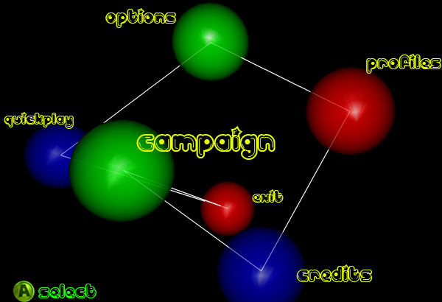

Options Menu
- Display
- Sound
- Controls
- Exit

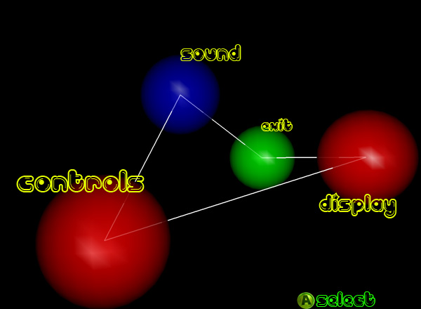

Campaign Menu

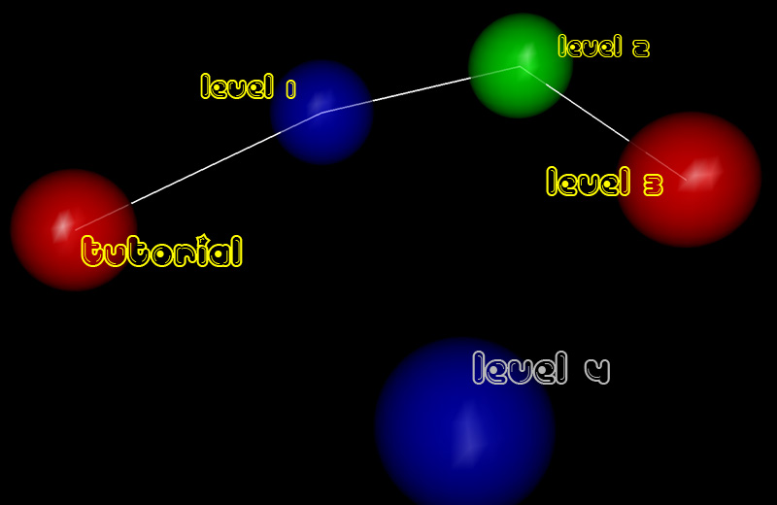

HUD
- Energy bar
  - Bottom center of screen.
  - Decreases when player uses the action button.
- Polarity Wheel
  - Bottom right hand corner of the screen.
  - Shows the player’s current polarity.
  - A pointer turns as player adjusts polarity.
- Builder Goal
  - Only exists in Builder mode.
  - 3 colored spheres corresponding to amount and color of atoms needed to complete the goal.
- Time
  - Only visible in Time Attack mode.
  - Top-Center of the screen.

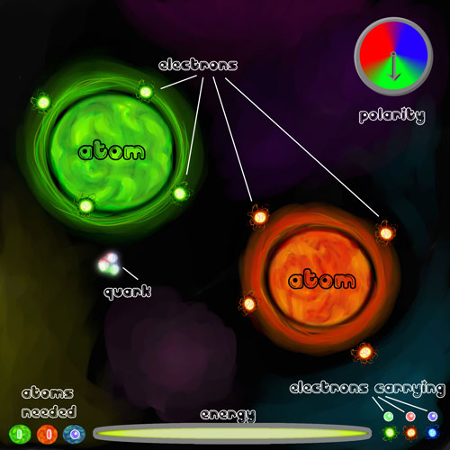
Navigation Mode HUD
Control Scheme
- Xbox360 Controller
  - Left Trigger - Neutral button
  - Left Bumper – Toggle Camera (3rd person/World view)
  - Left Stick – Change Polarity
  - Right Trigger – Action button
  - Right Bumper – Toggle State (Navigation/Collection)
  - Right Stick – Rotate Camera
  - A button – Select (menu items)
  - Start – Pause game

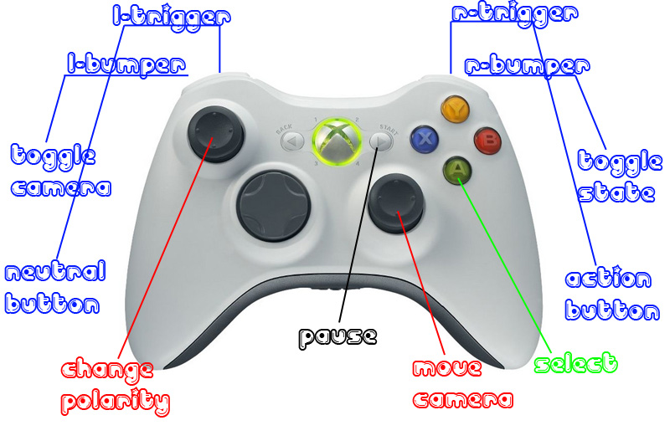

Keyboard
- Mouse Wheel – Change polarity
- Left Click – Action button/Select
- Right Click – Neutral button
- Spacebar + Mouse movement – Rotate Camera
- Tab – Toggle State (Navigation/Collection)
- Left Shift – Toggle Camera (3rd person/World view)
- Escape– Pause game
Interactive Rhythm
- Each level will last around 10 minutes.
- The game as a whole will be able to be completed in about 90 minutes.
- An average player’s game play will consist of three parts:
  - Navigate
    - The player, already having looked at the goal of the level, will move to the next atom that they need to bond or gather electrons from. They may choose to use Speed Boost in order to expedite this action.
    - Average time to complete: 10 seconds
  - Collect/Drop Off
    - The player will either need to collect or release electrons on the atom in order to progress to the next phase of bond forming.
    - Average time to complete: 5 seconds
  - Form bond
    - Once the required number of electrons has been distributed between two atoms, a bond will be formed.
    - Average time to complete: 3 seconds
- The player will repeat these steps in order to progress through each level, having an overall average game play pace of between 15 and 20 seconds.

How the Player Marks Progress

On the campaign screen, levels will be represented as atoms with a preview of each level inside. Once a player beats a level, a bond will be formed from that level to the next, similar to the bonds formed in actual game play. Progress within each level depends upon the current levels game mode.
The Builder mode is non-linear progression, so the only visual representation will be three spheres of blue, red, and green, with respective numbers of required atoms to be in the final molecule. Connect-The-Dots mode will show a percentage of how many atoms in the level have been bonded.
Lastly, the Time-Attack mode will have the same progression as the previous two modes, but with the added challenge of finishing them in the time required, which will be displayed at the top of the screen. The player has the option of revisiting old levels that have been unlocked in the Quick Play mode with the option of changing the puzzle type.

Achievements
Throughout Particle Panic the player will be able to unlock certain achievements which they can view on the profiles screen.

- Particle Accelerator
  - Beat a Time Attack level with more that 75% of time left
- Evasive Maneuvers
  - Avoid all Dark Matter in a level
- Polarity Pro
  - Don’t collide with any atoms
- Valence Master
  - Create the maximum bonds available on an atom
- Atomic Avenger
  - Destroy all Dark Matter within a level
- Solo Artist
  - Beat a level without any getting any power-ups
- Death Wish
  - If the player finishes a level and goes through Dark Matter 5 times or more
- Lab Assistant
  - Make 10 bonds in the game overall
- Journeyman
  - Make 25 bonds in the game overall
- Crazy Chemist
  - Make 50 bonds in the game overall
- Mad Scientist
  - Make 100 bonds in the game overall
- Over-Achiever
  - Complete every level on every mode

Detailed Design Breakdown
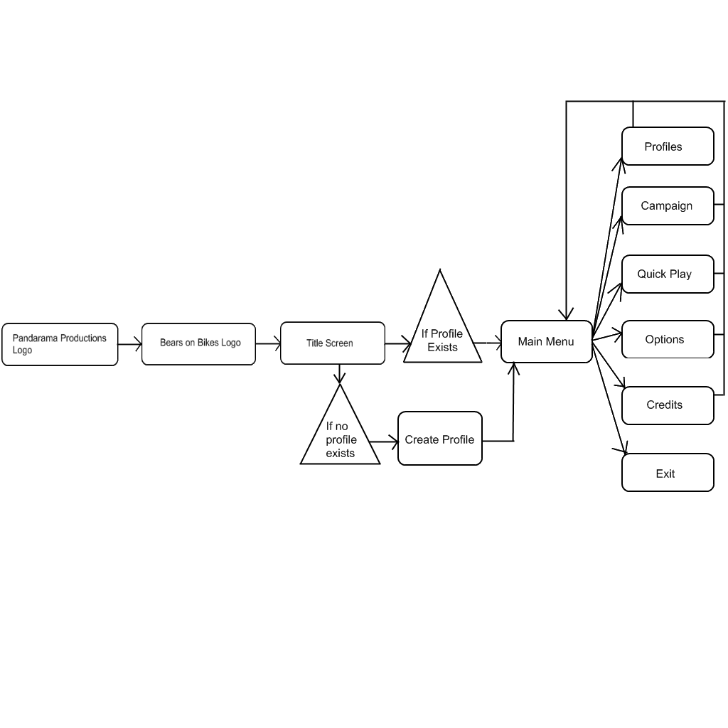
Front End Flow Chart

Front End Flow Chart Cont.

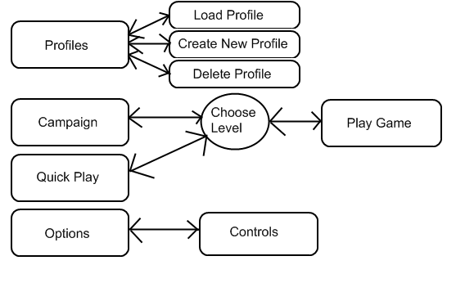

Game Flow Chart
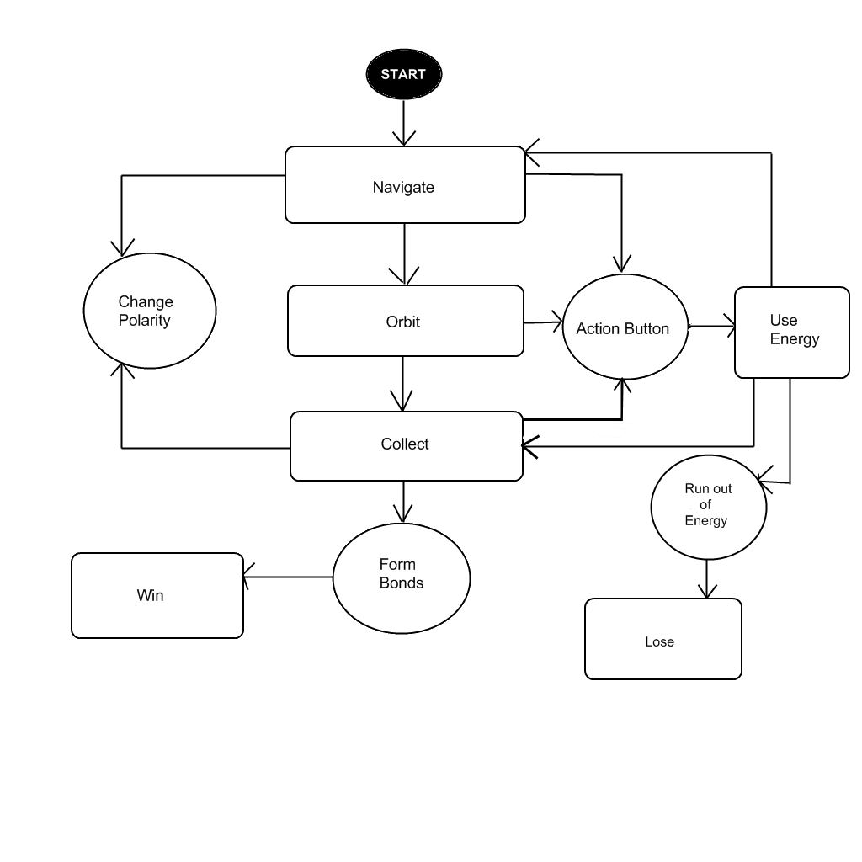
Glossary of Terms

Atom – Objects floating in the world that will cause gravitational pulls on Quark. Each atom will be the color red, green, or blue to represent its polarity.

Bond – A link created between atoms when the correct balance of elections has been achieved.

Builder – A mode of game play where the objective is to create a molecule using a designated number of each colored atom.

Collect – Use the action button to absorb electrons of the chosen polarity. This can only be done in the Collection State.

Collection State – While in this state, the player changes Quark’s polarity to collect or drop-off electrons. The player may only collect or drop-off electrons that match the current color of the polarity. While in this state, the polarity has no effect on the atoms. The player may only enter this state after being locked in Orbit.

Connect the Dots – A mode of game play where the objective is to create a specific shape/path using the bonds.

Drop Off – Use the neutral button to release electrons of the chosen polarity. This can only be done while in the Collection State.

Dark Matter – A hazard that, when passed through, will drain the player’s energy at the rate of 5% per second.

Electron – Small spheres that the player must move from atom to atom in order to create a bond. Electrons will circle around atoms and will be colored red, green, or blue.

Energy – This is the player’s power source. Using the action button will drain the Quark’s energy. If the player runs out of energy the game is over.

Energy Boost – A power-up that restores 25% of the player’s total energy.

Invulnerability – A power-up that will make the player immune to the adverse effects of Dark Matter for 30 seconds.

Molecule – A collection of atoms that have been bonded together.

Move – Use polarity to gravitate toward other atoms. If the player is in orbit, changing the polarity to any color other than the current one will cause them to detach and move to the nearest atom of that color.
Navigation State – While in this state, the player changes Quark’s polarity to affect the pull towards different atoms. During this time, the player will be pulled towards atoms that match the color of the current polarity. While in this state, the polarity has no affect on the electrons.

Neutrality – Quark has no polarity is not affected by any gravitational pulls and continues to move in his current direction.

Orbit – When the player approaches an atom at the proper speed they will begin to orbit the atom. When this occurs, the player will not be affected by the pull of any other atoms.

Polarity – Polarity is the gravitational pull between Quark and the various atoms and electrons. It is used for movement, collection, and drop-offs.

Polarity Wheel – This is the graphical representation of the player’s current polarity. On the HUD there will be a circle split into three sections: red, green, and blue. In the wheel there will be a needle that points to the current polarity and rotates as the player changes the polarity.

Quark – This is the main “character” of the game that the player takes control of. Quark will be made of several spheres mashed together and will take on the color of the current polarity.

Slingshot – An action that causes the player to increase their orbit speed around an atom. An arrow will appear to show how fast and in what direction the player will travel.

Slingshot Arrow – A visual representation of the speed and direction that player will travel in when performing a Slingshot.

Speed Boost (Locked in Orbit) – Use the action button to increase orbit speed, thus allowing the player to suddenly go neutral and slingshot themselves off of the atom.

Speed Boost (Navigation) – Increases Quark’s speed in his current direction by using the action button.

Time Attack – A mode of game play that requires the player to complete a Builder or Connect the Dots in a set amount of time.

Tractor Beam – A power-up that allows the player to collect electrons from a long distance. This effect lasts until the player uses up its associated power.

Unlimited Energy – A power-up that allows the player to perform any action without using any energy for 30 seconds.
Characters

Name/ID
Quark

Brief Description
Quark is the representation of the player inside of the game world. He is whom the player uses to perform all of the actions required to build molecules and complete the game’s goals.

Visual Design
Quark is a blob like entity. He is a collection of three spheres of green, blue, and red, that mold and combine with each other in a semi-random fashion. He has a faint glow of the color his certain polarity is set to. When he is neutral or inactive, he will have no glow emanating from him.

Behaviors
- Move
- Orbit
- Collect
- Drop Off
- Speed Boost
  - Locked in Orbit
  - Navigation Mode

Attributes
- States
  - Navigation
  - Collection
  - Orbit
  - Neutral
- Collection/Drop Off Rate
  - 1 electron per second
- Max Electrons
  - 8
- Current Electrons
- Normal Speed
  - Navigation
    - Max 5 units per second
  - Orbit
    - 10 units per second
- Speed Boost
  - Navigation
    - Max 10 units per second
  - Orbit
    - 15 units per second

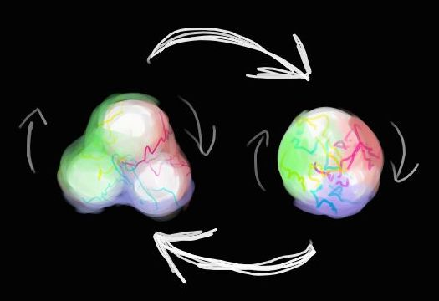
Name/ID
Atom

Brief Description
Atoms are the objects in the world that the player is trying to create bonds between. They will each have their own polarity and gravitational force that affect the way the player can move.

Visual Design
Each Atom can be red, green, or blue. This will affect what color Quark’s polarity needs to be in order to be attracted to that particular Atom. They will all have a glow effect that matches the color of their polarity, and the body of the Atom is a swirl of different shades of that color.

Attributes
- Polarity
  - Red
  - Green
  - Blue
- Diameter
  - 7-10 units
- Weight
  - 700-1000 units
- Max Electrons
  - 8
- Current Red Electrons
- Current Green Electrons
- Current Blue Electrons
- Max Bonds
  - 4
- Current Bonds
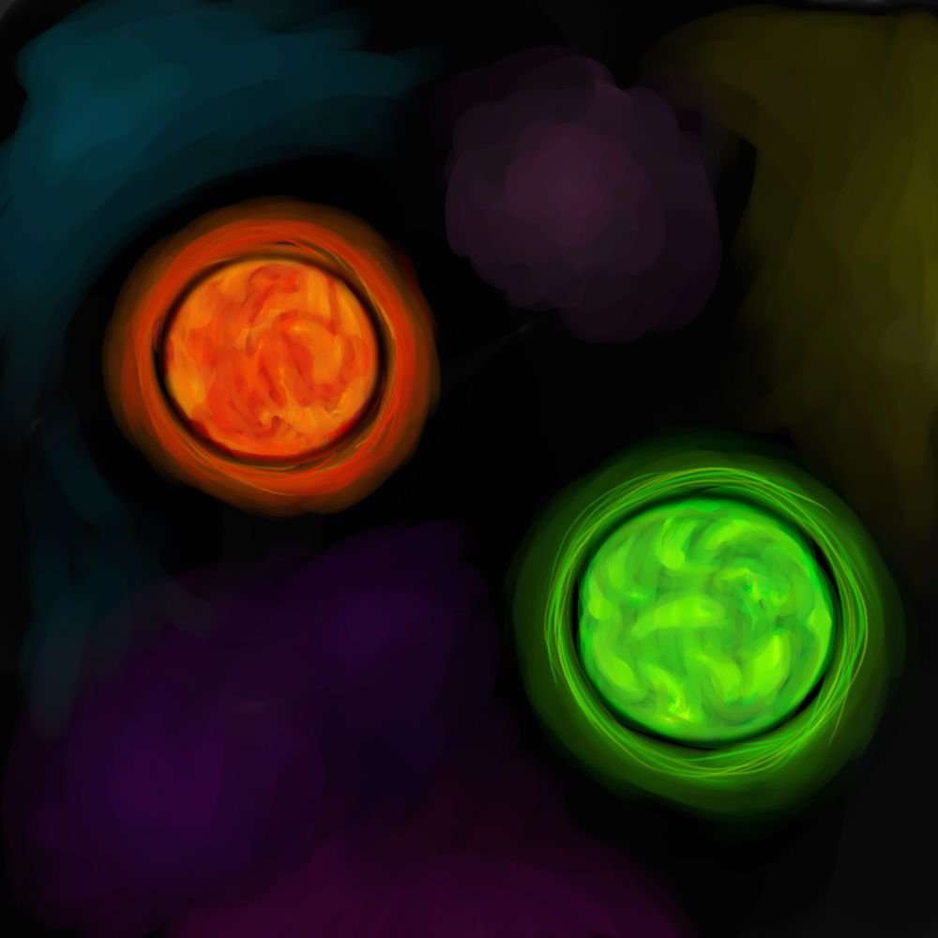
Red and Green Atoms

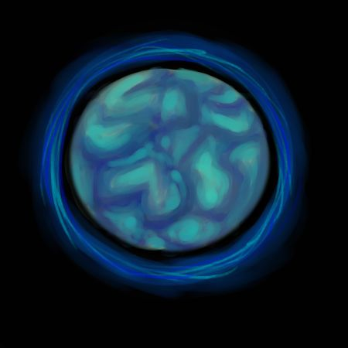
Blue Atom
Power-ups

Collision
- When the player collides with a power-up, a sound will be played and the player will gain the effect of the power-up.
- The power-up will move towards the player and absorb into the player when they come close enough. There will be a shockwave-like effect as the visual representation.

Name/ID
Invulnerability

Brief Description
This causes the player to become immune to the adverse effects of Dark Matter for 30 seconds.

Visual Design
This power up will look like a translucent, shiny orb. It will be smaller than any atom in the level but larger than any electron. The inside of the orb will have an electrical sparkle particle effect on the inside that will be white in color.

Attributes
- Effect duration
  - 30 seconds
- Collection radius
  - 5 units

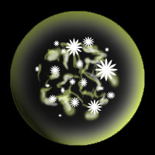
Name/ID
Unlimited Energy

Brief Description
This allows the player to perform any action without draining energy. The effect lasts for 30 seconds.

Visual Design
This power up will look like a translucent, shiny orb. It will be smaller than any atom yet larger than any electron. It will have a yellow pulsating neon effect on the inside.

Attributes
- Effect duration
  - 30 seconds
- Collection radius
  - 5 units

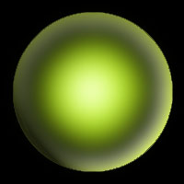
Name/ID
Tractor Beam

Brief Description
Once this is obtained the player can collect electrons from a further distance. The tractor bar has its own energy that will deplete as it is used. When all of the energy is consumed the player loses the power up.

Visual Design
This is a translucent shiny orb that is the same size as all other power-ups. It will have a particle effect of red, green, and blue particles constantly being sucked into the center.

Attributes
- Effect rate
  - 10% per second
- Collection radius
  - 5 units

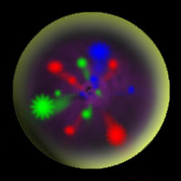
Name/ID
Energy Boost

Brief Description
This restores a quarter of the player’s energy bar, allowing the player to perform more actions without running out of energy.

Visual Design
The Energy power-up will be the same size as all other power-ups, and appear and as a shiny translucent orb. Inside this orb there will be a bright red pulsating and glowing effect.

Attributes
- Effect amount
  - 25% of player’s total energy
- Collection radius
  - 5 units

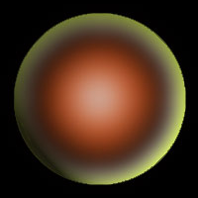

Levels and Maps

Level Travel
The main character moves around the world by gravitating to different atoms by changing their polarity. See the character information section for specific abilities and attributes.

Level Walkthroughs
Since Particle Panic is a puzzle game, the player can solve each level in more than one way. Level Walkthroughs in this document provide a possible solution to each level, but the player is not limited to doing it the specified way.

Scale
- Quark – 1 unit diameter
- Atoms – 7-10 unit diameter
- Electrons – ½ unit diameter
- Bonds – 3 unit diameter, 10 unit length
- Dark Matter – 10-30 cubic units
- Power-ups – 1 unit diameter
- Level Bound – 10 cubic units per particle

Environmental Interactions - Behaviors
- Bond forming
  - Bonds are formed by equalizing electron counts between two different atoms, and are required to advance through the level.
  - If a bond is formed through Dark Matter, the Dark Matter will be destroyed.
- Wall collision
  - If Quark collides with any of the level’s boundaries, he will bounce back and the wall will light up.
  - Atoms and power-ups will simply bounce off.

Ambient Environmental Aspects/Objects in the Level
- Particle effects
  - Collision between two atoms
  - Collision between Quark and atoms
  - Bond effects
  - Electron collection/release
  - Slingshot tail effect
- Sound effects
  - Collision between two atoms
  - Collision between Quark and atoms
  - Bond formation/destruction
  - Electron collection/release
  - Slingshot charging/release
  - Collision between Quark and walls
  - Collision between atoms and walls
- Background music
- Background visual

Name/ID
Tutorial

Goal
Make a molecule consisting of a red and a blue atom.

Attributes
- Atoms – 3
  - 1 red, 1 green, 1 blue
- Electrons – 6
  - 2 per particle

Time
Average play time: 5 minutes

Map
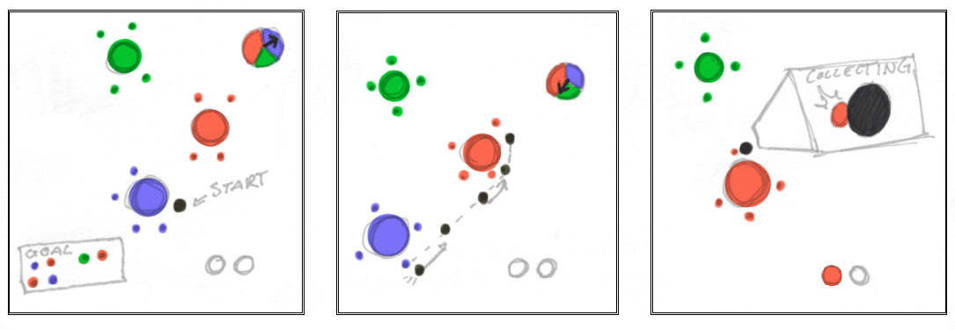
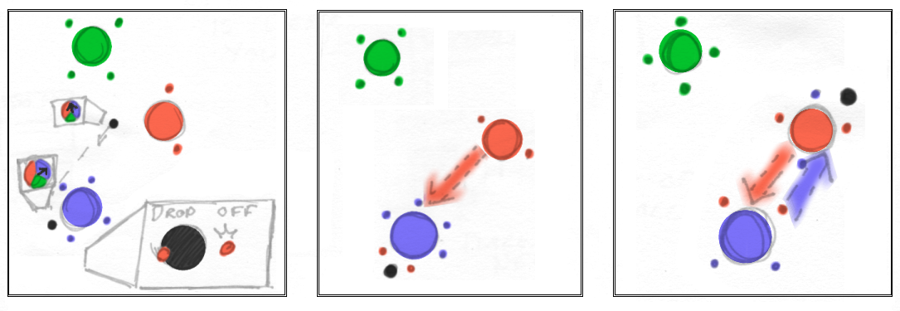
.
Level Walkthrough – Verbal Map
- Navigate towards blue atom
  - Absorb both blue electrons
- Navigate towards red atom
  - Absorb both red electrons
  - Drop off both blue electrons
- Navigate back to blue atom
  - Drop off both red atoms
Name/ID
Level 1

Goal
Make a molecule consisting of a red, blue, and a green atom.

Attributes
- Atoms – 3
  - 1 red, 1 green, 1 blue
- Electrons – 8
  - 2 blue, 2 red, 4 green
Time
Average play time: 3 minutes
Time Attack Mode: 2 minutes

Map
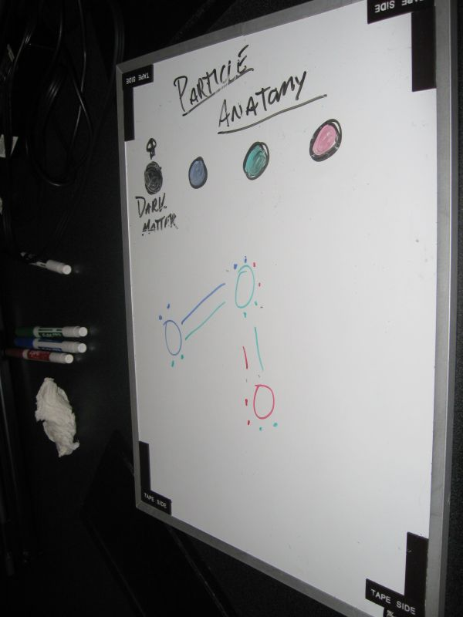

Level Walkthrough – Verbal Map
- Navigate towards blue atom
  - Absorb all two blue electrons
- Navigate towards green atom
  - Absorb both green electrons
  - Drop off two blue electrons
- Navigate back to blue atom
  - Drop off both green atoms
- Navigate to red atom
  - Drop off two green electrons
  - Absorb two red electrons
- Navigate back to green
  - Drop off two red electrons
Name/ID
Level 2

Goal
Connect the two atoms as shown by the temporary bond.

Attributes
- Atoms – 7
  - 2 red, 3 green, 2 blue
- Electrons – 12
  - 4 blue, 4 red, 4 green

Time
Average play time: 5 minutes
Time Attack Mode: 3 minutes

Map
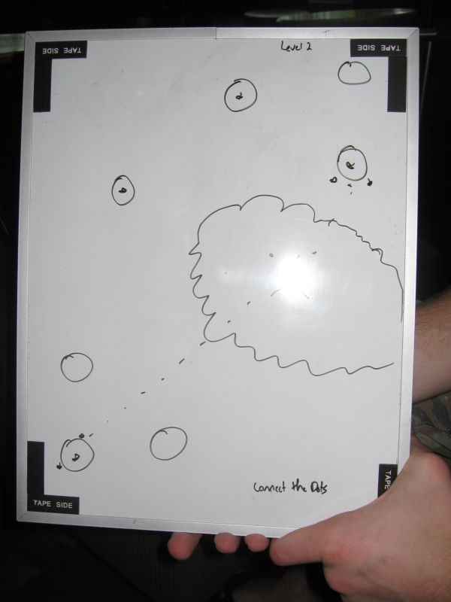

Level Walkthrough – Verbal Map
- Navigate towards blue atom
  - Absorb all blue electrons
- Navigate towards red atom
  - Slingshot to the lone green atom to the left of the dark matter
- Slingshot from green to next molecule cluster
- Navigate towards only red atom in that molecule
  - Drop off all blue electrons
  - Absorb all red electrons
- Navigate back to original blue atom
  - Slingshot back to lone green atom
  - Slingshot back to original molecule cluster
- Navigate back to blue
  - Drop off all red electrons

Interactive System

In Particle Panic the player has two main ways of interacting with the world and solving puzzles. The first is using the polarity attributes to navigate the world, the second allows the player to collect and drop off electrons. Electrons are the main “currency” of the game. When and equilibrium of electrons is created between two atoms i.e. a Red atom has one red electron and one blue electron and a Blue atom has one red and one blue electron, a bond is formed. The player must form bonds to complete the level specific goal, whether it is a Time Attack, Builder, or Connect the Dots mode. The player has an Action button and a Neutral button to perform abilities in both modes. Holding down the action button in either mode depletes a certain amount of energy from the player’s energy bar for the time held. The player is also able to change the camera perspective at anytime in the game. By using the joystick/mouse the player can move the rotate the camera around the player in the 3rd person perspective. There will also be a button that zooms out so the player can view the entire map. They will have the ability to rotate the camera around to see different angles of the world.

Polarity Movement (Free Roaming)
- Player moves through the world by manipulating polarity attributes.
- Polarity Wheel shows the player their current polarity (see Interface).
- Player gravitates toward the nearest atom of that polarity.
- Holding down the Action button makes the player gravitate faster towards an atom.
- Holding down the Neutral button “neutralizes” the polarity.
  - Grays out the polarity wheel
  - No gravitational force will affect player
  - Current momentum is conserved
  - Player will begin to slow down
- To orbit an atom:
  - Player must be in close proximity of the atom
  - Player must maintain proximity for a short amount of time
  - Player’s speed must not exceed a certain amount

Orbital State
- Camera focuses on atom the player is orbiting.
- Player has the ability to collect electrons from that atom.
  - Switching to Collect mode does not break orbit
  - Player can either drop off or absorb electrons
- Player has the ability to Slingshot
  - Hold down the Action button to Slingshot
  - Release Action button to cancel Slingshot
  - Hollowed arrow appears in direction camera is facing
  - Arrow fills up as player continues to charge
  - The more the charge the faster the player will be ejected in the direction of the arrow
  - Pressing the Neutral button shoots the in the direction of the arrow
  - Player can use the camera to change direction of the arrow
- Player can leave orbit by holding the Neutral button.

Collection System
- Player can carry up to eight electrons at a time.
- Player can only collect or drop off electrons while orbiting.
- Player only absorbs or deposits electrons of his current polarity.
- Player must hold down Action button to absorb electrons
  - Consumes significantly less energy than navigation mode
  - Sucks electrons toward the player at a consistent rate
  - When released electrons stop gravitating toward player
- Player can hold the Neutral button to deposit atoms
  - Releases electrons at a consistent rate
  - Only releases electrons of the current polarity

Special Abilities

Slingshot Mode

- Only available while player is orbiting an atom
- The Slingshot Arrow will appear and point in the direction the camera is facing
- Camera will zoom out slightly for better view
- Holding down the Action button charges your shot
  - Arrow begins to fill up
  - Arrow represents the speed and direction of shot
  - Releasing the Action button cancels the shot
  - Hitting the Neutral button launches the player
- Energy bar will be drained according to power of the shot
  - No energy deducted for canceling

Tractor Beam Mode

- Only available after tractor beam pickup has been collected
- A secondary energy bar will appear under the primary one
- A light beam will emanate from the player that is the color of the current polarity
- Atoms will light up when the beam intersects with them
  - Holding the Action button down draws electrons to you remotely from that atom
  - Only collects electrons of the current polarity
  - Holding the Action button depletes the secondary energy bar
- This ability is lost when the secondary energy is depleted
Game Logic, Algorithms, and Rules

Interaction Component Matrix

See the accompanying Excel sheet for the full Interaction Component Matrix.

Key Game Algorithms

Gravitational Acceleration

float Acceleration_Gravity (Object object1, Object object2)
{
Return GravitationalConstant * object2.mass / (DistanceBetweenObjects)squared
}

Player State Contextual Switch

switch (player.GetState())
{
case NAVIGATE_STATE:
{
if (player.forwardMomentum < nearestAtom.gravitationalPull)
player.SetState(ORBIT_STATE);
}
case ORBIT_STATE:
{
if (player.forwardMomentum > nearestAtom.gravitationalPull)
player.SetState(NAVIGATE_STATE);
}
}

Check for Possible Bonds

if (player just switched out of collection mode…)
{
for (int i = 0; i < nearestAtom.electrons.size(); ++i)
{
if (i + 1 % 2 == 0)
{
switch (nearestAtom.electrons [i].type)
{
case RED:
{
for (int j = 0; j < redAtoms.size(); ++j)
redAtoms[j].CheckElectrons(i, RED);
}
case GREEN:
{
for (int j = 0; j < greenAtomList.size(); ++j)
greenAtoms [j].CheckElectrons(i, GRN);
}
case BLUE:
{
for (int j = 0; j < blueAtomList.size(); ++j)
blueAtoms [j].CheckElectrons(i, BLUE);
}
}
}
}
}

bool Atom::CheckElectrons(int num, int type)
{
switch (type)
{
case RED:
{
if (redElectrons.size() == num)
return true;
}
case GREEN:
{
if (greenElectrons.size() == num)
return true;
}
case BLUE:
{
if (blueElectrons.size() == num)
return true;
}
}

return false;
}
FAQ

- What is Particle Panic?
  - Particle Panic is an action oriented puzzle game in which the player creates bonds between different atoms to create various molecules.
- How do you move around the world?
  - Navigation in the game is accomplished by giving the main character a polarity, which will make him attract to the particle that matches that polarity.
- How do you create a bond?
  - Bonds are created by creating electron equilibrium between 2 atoms. This is accomplished by transferring collecting and dropping off electrons to and from atoms.
- How do you collect and drop off electrons?
  - When the player is orbiting an atom, they may then enter collection mode. Then, they can select the polarity of the type of electron they would like to collect, and hold down the Action button to absorb them.
- How do you orbit an atom?
  - If the player comes close enough to an atom and his forward momentum is less than the gravitational pull of that atom, he will be sucked into it and enter an orbit around said atom.
- How do you enter collection mode?
  - The player will be able to toggle between collection mode and navigation mode by pressing a button. The player can only enter collection mode when orbiting an atom.
- What is the Tractor Beam power-up?
  - The Tractor Beam power-up gives the player the ability to pull electrons from far off atoms when in collection mode.
- What is the Energy Boost power-up?
  - The Energy Boost power-up will restore 25% of the player’s energy bar.
- What is the Unlimited Energy power-up?
  - The Unlimited Energy power-up will give the player unlimited energy for a limited time.
- What is the Invulnerability power-up?
  - The Invulnerability power-up will make the player immune to the negative effects of Dark Matter for a limited time.
- What is Dark Matter?
  - Dark Matter is the “enemy” of the game. It can spawn randomly in some levels, and when passed through, will drain the player’s energy.
- What is Energy?
  - Energy is the player’s “health”. It is used up when the player performs actions, or if he passes through Dark Matter. Energy is replenished when the player makes a bond, or picks up an Energy Boost power-up.
- How does the player perform actions?
  - The Action Button will perform all of the actions in the game. These include collecting and releasing electrons, and when in navigation mode, using the Speed Boost.
- What is Speed Boost?
  - Speed Boost is an action the player can perform that will either increase their speed when they are moving freely through the world, or if they are orbiting, it will greatly increase their orbit speed, which they can then use to Slingshot themselves off of the particle by going Neutral. Using this ability will drain the player’s energy.
- How and why does the player go Neutral?
  - The player can go Neutral at any time by pressing the Neutral button, which will essentially deselect their polarity. This will cause them to have no attraction to any particle, thus making them travel in their last direction.
- How does the player Slingshot themselves?
  - This action is performed by using the Speed Boost ability in conjunction with the Neutral function. If the player uses Speed Boost while in orbit to greatly increase their orbit speed, and then immediately go neutral, they will shoot away from the atom in the direction indicated by the display.
- What is the target audience of this game?
  - This game will be target towards the casual gamer audience, such as the Xbox Live Arcade or Pop Cap Games demographic.
- What type of physics system will you use?
  - Particle Panic will use a state based Newtonian physics system that will be able to seamlessly transition between a free-roaming movement and navigation mode and an orbital mode used for performing actions.
- When will the bonds actually be formed?
  - When the player switches out of Collection Mode, the system will check for all possible bonds and will then create them accordingly. However, during the Collection Mode, the player will be given a visual update about what bonds will be formed before he switches out of this mode.
Reference of Key Elements

Scoring

The player typically advances through the game by successfully completing the molecule that was specified as the goal for that particular level. There is no specific scoring system based around this goal, just whether or not the player has completed it or not.
However, the player does have energy, which could be considered his health. This energy is reduced by using the action button, depending upon the activity, and the player loses when their energy reaches zero. Energy can be restored by creating bonds, or by picking up power-ups.

Winning/Losing

The player wins a level by successfully completing the associated goal or goals for that level. These could include creating a specific molecule in Builder mode, a Connect the Dots mode, where the player must make specific bonds between atoms, or a Time Attack mode, where either of the previous two modes could be used with the addition of a time limit.
During the campaign mode, the player wins the game when all of the levels have been successfully completed in order. The player can lose mainly by running out of energy on any given level, or if they run out of time on the time-attack mode.

Transitions

The player’s progress will only be saved during the campaign mode, where upon successful completion of each level, their current completion state will be written to disk. This system will involve the use of profiles, where more than one player can have their own save point for a campaign.
There will not be any specific load feature for the game, the player only has to enter the campaign screen and select the most recent level that they have unlocked to continue. Also, each level will give the player the option to restart the current level from the beginning.

Rewards

After the player completes a level in the Campaign Mode, that level will be available in Quick Play with other options available. For example, if the player completes a level in that has a builder requirement, the level may be playable in Quick Play with a Time Attack option.
Art and Production Design

3D Art & Animation Deliverables

All 3D art should be in .x file format

- Atoms
- Electrons
- Quark
- Bonds
- Dark Matter
- Power-Ups
- World Bounds
- Menu Items
- Slingshot Arrow

2D Art (HUD/Menu/Particle/Textures) Deliverables

All 2D art should be in .dds file format (DXT5 compression)

- Fonts
- Menu Items
- Atoms
  - Electricity effects
  - Bond effects
  - Action effects
- HUD Items
  - Polarity wheel
  - Energy bar
  - Particle/Electron indicators
- Background
- Textures
  - Atoms
  - Electrons
  - Quark
  - Dark Matter

Sound Effects Deliverables

All sound files should be in .wav file format

- Atoms
  - Collision
    - Quark
    - Atoms
- Electrons
  - Collection
  - Release
  - Ambience
- Bonds
  - Creation
  - Destruction
  - Ambience
  - Collision
- Quark
  - Speed Boost
  - Neutral
  - Collision
    - Walls
  - Energy usage
  - Low energy
- Power-ups
  - Ambience
  - Collect
  - Effect
    - Tractor Beam
    - Invulnerability
    - Energy Boost
    - Unlimited Energy
- Menu
  - Select
  - Back
  - Change screen
- Level Complete
- Level Failed
- Time low

Music Deliverables

All music should be in .wav file format

- Menu
- Game
  - Builder
  - Connect the Dots
  - Time Attack

