Publishing Document

Particle Panic!



Bears on Bikes

Andrew Zeck | dewhacker@gmail.com
Dustin Berkey | orionshadekiller@gmail.com
Jacob Yelinek | nukekillsall@gmail.com
Michael Tomasino | mtomasino@hotmail.com
J. Domagala | domagala.j.l@gmail.com
Tom Cassera | mentalassassin@gmail.com

Game Charter 1
Vision Statement 1
Meeting Schedule 1
Hours Worked per Week 1
When Things Go Wrong 1
Decision-Making Process 2
Rules of Conduct 2
Team Roles 3
Executive Summary 4
High Concept 4
Locale 4
Genre 4
Basic Controls 4
Game Goal 5
Target Platform 6
Marketing & Target Audience 6
Game Walkthrough/Overview 6
Key Features 7
Comparative Products 7
How this Product Stacks up 7
Treatment 8
Dust Jacket Story 8
Game Story 8
Characters 9
Power-ups 10
Art and Production Design 17
Art & Animation Style 17
Sound Effects Style 18
Music Style 18
Storyboards and Sample Art 18

Game Charter

Vision Statement

We will deliver and complete a polished title in 5 months by maintaining effective communication, being honest with each other, and keep open minds and ears to all group members. We will create realistic schedules by analyzing individual skills and appropriately portioning time. We will strive to complete assigned individual tasks by deadlines, and go out of our way to help members running behind by offering assistance and redistributing work loads. By adhering to our design document we will create a finished product that will be the representation of our cumulative goals and ideas.

Meeting Schedule

We will meet up 4 times a week (not including class days) at a group member’s apartment or at the school. Meetings will begin at 1pm but are subject to change if problems arise. The project lead will start the meeting and bring all members up to date on the current progress of the group as a whole. We will discuss any individual issues we are having on assigned tasks and address group concerns. Each team member is required to be present and participate in the meeting and state their current progress. If someone needs extra help, we will divide work loads accordingly. These meetings will not exceed one hour in length.

Hours Worked per Week

Each team member is required to work 50 hours per week. No one will exceed a 60 hour work week. We will work as a group 8 hours a day, 5 days a week, and every member is responsible to work another 10 hours at their leisure, individually or with others.

When Things Go Wrong

If a group member has an emergency they will contact the project lead by phone, who will subsequently contact the other members. We will avoid risks if an emergency arises by keeping each member up to date on our situations and what work needs to be done

Decision-Making Process

Concerning a decision that will affect the entire project, everyone will be notified and informed on the change at the next group meeting. The group will have to unanimously agree on the decision before it is implemented. If this discussion exceeds a half hour in length, an alternate choice or compromise must be agreed upon or the issue will be brought to our EP for the final decision.

Rules of Conduct

1. Treat all team members with respect (no insulting, shouting, bickering, physical aggression).

2. Keep personal problems at home. Maintain a professional atmosphere.

3. Leave your ego at the door.

4. Hygiene is paramount.

5. Don’t be more than 10 minutes late for meetings or work sessions.

6. Notify all members in a minimum of 5 days in advance of any pre-planned activity.

7. Every other week take some time off to spend with the group and do a fun activity together.

8. If two group members are having personal issues, contact the project leader for mediation. If any group member has a problem with the project leader feel free to discuss it with him, if necessary the issue will be brought to our EP.

9. Be completely honest with yourself and your teammates. State your abilities as accurately as possible. Don’t hesitate to ask for help.

10. Commit yourself to the project and your teammates in the fullest degree possible.

Anytime a rule is broken, it is recorded at that time by the project lead and signed off by the offender (even if it is the project lead). If these rules are broken three times in a week by one member, the project lead will notify the EP and proper consequences will be discussed.

Team Roles

Project Lead – Andrew Zeck
Technical Lead – Michael Tomasino
Asset Lead – J. Domagala
Game play – Tom Cassera
Q & A – Jacob Yelinek
Design – Dustin Berkey
Executive Summary

High Concept

Navigate through a quantum world to build the atomic bonds that will save the universe.

Locale

Particle Panic! takes place in the quantum universe, where the player will be creating bonds between atoms. The atoms will be one of three colors: red, green, or blue. Also, each atom will have several electrons with similar color schemes swirling around it, much like you see in science books. Since the quantum universe is not fully explored, the backgrounds and art styles will be very abstract, with liberal use of swirling colors and bright, almost neon particles whizzing around the world. The general theme of the game, much like real quantum physics, is controlled chaos.

Genre

Puzzle

Basic Controls

The player controls Quark, the main character of the game. The player has the ability to maneuver the camera in a 3rd person perspective with the mouse/joystick. When Quark is moving about in atomic space, the camera is focused on the quark. When the Quark is locked in orbit around an atom, the camera will be focused on the atom. The player is also able to zoom out to view the entire map. In this mode the camera control will maintain consistency, allowing the player to view the map in a 3D 3rd person perspective.
A button will toggle the Quark navigation and collection mode. An activation button will initiate the proper activity, such as gravitation in navigation mode and sucking in electrons in collection mode. A deactivation button will do the opposite, turning off the polarity attributes in navigation mode, and releasing electrons in collection mode. The player is permitted to pause the game at any time with a button press.

Game Goal

The overall goal of the game is to go navigate through the level and solve the puzzle which is based on the puzzle type of that level. Once the player solves the current puzzle, the road to the next stage will open and the player may continue on. Each level’s puzzle could be one of three types:

Builder:
In the builder puzzle, the player is assigned a certain number of each color of atom that needs to be in their final molecule. The player can connect any atom with any other atom and has free roam to complete the task as they wish.

Connect The Dots:
In connect the dots, the player is shown a specific path that they need to follow to complete their molecule. They can create additional bonds if they must as long as they complete the original course objective.

Time Attack:
The time attack mode is just like the builder, where the player is given a specific number of atoms of each color that they must have in their final molecule. The difference is that there is a time limit in which they must complete the task. The time will vary depending on the difficulty of the given puzzle.
Target Platform

Primary Platform
- Windows based PCs

Minimum Requirements:
- Windows System 2000/XP OS
- Intel Pentium IV 1.5 GHz or AMD XP 1500+ MHz
- 512 MB RAM
- 64 MB 3D graphics card with Hardware Transform and Lighting, such as NVIDIA GeForce FX 5700 class card or above
- Two-button scroll-wheel mouse

Secondary Platform
- Xbox 360 (XBLA)

Marketing & Target Audience

We are aiming towards 16-35 year old males and 35-50 year old females, who are casual gamers. For the 16-35 males, these include people in high-school, college, or a job who cannot sit down and spend hours a day playing a game. We are allowing them to sit down, play for a few minutes, and relax. The majority of puzzle game players are 35-50 year old females, therefore our target is feasible.

Game Walkthrough/Overview

The player will start at a random position in the level, from where they must select a polarity which will cause them to gravitate toward the nearest atom of that same polarity. This essentially starts the game’s navigation. Once the player is moving, they then must move from atom to atom by either utilizing the action button, which will increase their speed and give them a specific direction in which to launch themselves, or by simply changing their polarity.
Once the player reaches the atom they desire, they can start collecting the electrons that orbit that atom. After they acquire all of the electrons they need, they will navigate to another atom that they would like to bond to. They then release the electrons they initially collected, and repeat the collection process with this new atom, eventually returning to the previous atom.
After the electrons are balanced between the two atoms, a bond will be formed, pulling each atom, sometimes violently, towards each other. The player will repeat this process, forming bonds and pulling different atoms together until the level’s end goal is reached.

Key Features

Gameplay “A” Features:
  - Gravitational movement
  - Item Collection
  - Strategic Building

Gameplay “B” Features:
  - Dark matter hazards
  - Power-Ups
  - Varied game modes

Comparative Products

Scorched Planets
Mario Galaxy

How this Product Stacks up

The similarities between Particle Panic! and Mario Galaxy are only found in a few levels of Mario Galaxy where gravity platforms attract Mario towards them. Mario can jump over the side of one of these platforms and wind up on the other side due to the gravity. Also, he can have his path be changed if he jumps to close to other gravitational platforms. Particle Panic! will have this gravitational pull but instead of the player walking and being planted on the edge of the objects he will be in orbit of atoms he’s being pulled towards.
With Scorched Planets the projectiles are attracted to planets and hopefully slam into the enemy planets. If the projectiles are attracted to planets but don’t collide, the path has been effected and may cause them to be attracted to a different planet. This is how Quark in Particle Panic! is going to travel, but we don’t want to have Quark slam into the atoms but rather orbit them and continue to move to other atoms.
Treatment

Dust Jacket Story

The universe is falling to pieces and only Quark can save it! It’s up to Quark to travel through atomic space by using his magnetic pull towards other atoms. Help Quark transfer and balance electrons to reform bonds between atoms and prevent the tearing of the universe!

Game Story

Dark matter has begun to spread into your world. It’s disturbing and destructive force is wreaking utter chaos at the atomic level! In the midst of this quantum pandemonium, a mysterious quark with extraordinary powers has emerged. With the ability to manipulate all the sub-atomic forces, it has the power to reform bonds between atoms and restore natural order. The quark, cleverly named Quark, is the last hope for balance in the universe. He traverses the unfamiliar world by traveling from cluster to cluster of molecules and collecting electrons. Using these collected electrons, Quark places them at the right atomic particles to create equilibrium and reform the bonds essential to holding the elements together. After navigating this hectic environment, Quark uses his powers and skills to repair the threads that maintain atomic order and returns the universe to its peaceful state.
Characters

Name/ID
Quark

Brief Description
Quark is the representation of the player inside of the game world. He is whom the player uses to perform all of the actions required to build molecules and complete the game’s goals.

Visual Design
Quark is a blob like entity. He is a collection of three spheres colored red, green, and blue, that mold and combine with each other in a semi-random fashion. He has a faint glow of the color his certain polarity is set to. When he is neutral or inactive, he will have no glow emanating from him.

Back Story
He was formed in the utter chaos of the sub-atomic turmoil.

Dialogue
Quark has no dialogue.

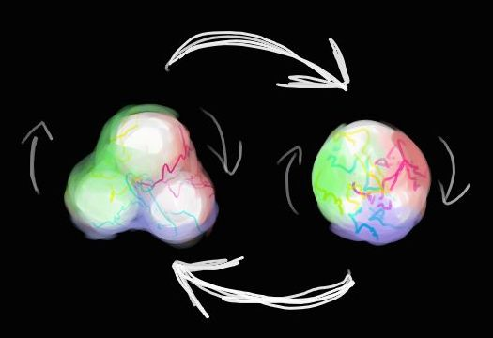
Power-ups

Name/ID
Invulnerability

Brief Description
When the player is within a short range of the power-up, they will absorb it and become invulnerable to any effects from Dark Matter for 30 seconds.

Visual Design
This power up will look like a translucent, shiny orb. It will be smaller than any atom in the level, but larger than any electron. On the inside of the orb there will be an electric sparkly particle effect that is white in color.

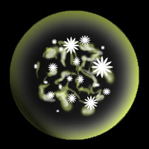
Name/ID
Unlimited Energy

Brief Description
It is absorbed when the player is in a short range of it. This gives the player an unlimited amount of energy for 30 seconds (i.e. the player will not lose any energy when using the action button).

Visual Design
This will also be a translucent shiny orb. It will be the same size as any of the other pickups, smaller than any atom yet larger than any electron. It will have a pulsating neon effect that is the same color as the bonds (electric yellow).

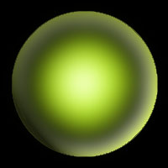
Name/ID
Tractor beam

Brief Description
It is absorbed when the player is in a short range of it. This power-up will give the player a special ability to shoot a tractor beam at any atom and collect electrons of the certain polarity by using the action button.
This will affect the player’s collection mode, by giving them a similar perspective as if they were going to slingshot. They will have a light ray projecting from them that will be the same color as the current polarity. Holding the action button down will suck electrons of the polarity from the atom the ray is pointing at. This will create a secondary energy bar below the main energy meter. Using this power-up will deplete that secondary bar. Once depleted, this ability will be lost.

Visual Design
This is a translucent shiny orb that is the same size as all other power-ups. It will have a particle effect of red, green, and blue particles that are constantly being sucked into the center.

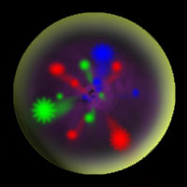
Name/ID
Energy

Brief Description
It is absorbed when the player is in a short range of it. When obtaining this power-up the player’s energy bar will refill by 25% (can not go over 100%).

Visual Design
The Energy power-up will be the same size as all other power-ups, and appear and a shiny translucent orb. Inside this orb there will be a pulsating, glowing bright red effect that is similar to the effect that happens when your energy bar is critical.

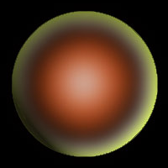
Levels and Maps

Name/ID
Tutorial

Goal
Make a molecule consisting of a red and a blue atom.

Brief Description
This is the tutorial level for the game. It is very simple, and since it is intended to teach the player how to play the game, it is has a very easy goal. The player will be taken through several different screens informing them how to navigate around the world, collect electrons, and from bonds.

Visual Design
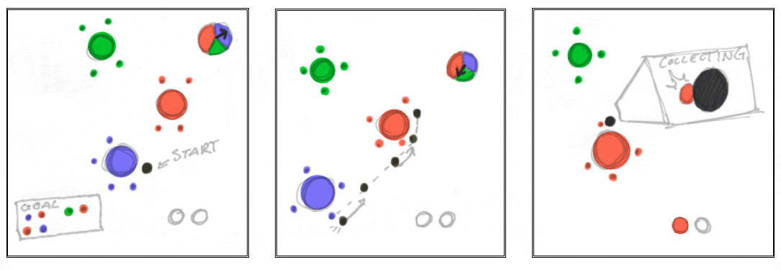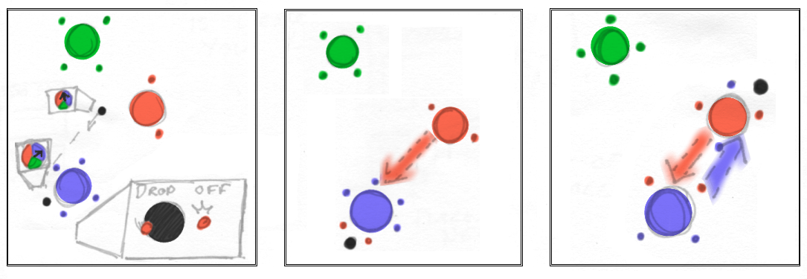
Name/ID
Level 1

Goal
Make a molecule consisting of a red, a blue, and a green atom.

Brief Description
This level builds upon the same techniques as the last one, having the player create bonds by navigating and collecting electrons. It has the same visual style and similar layout as the previous level.

Visual Design
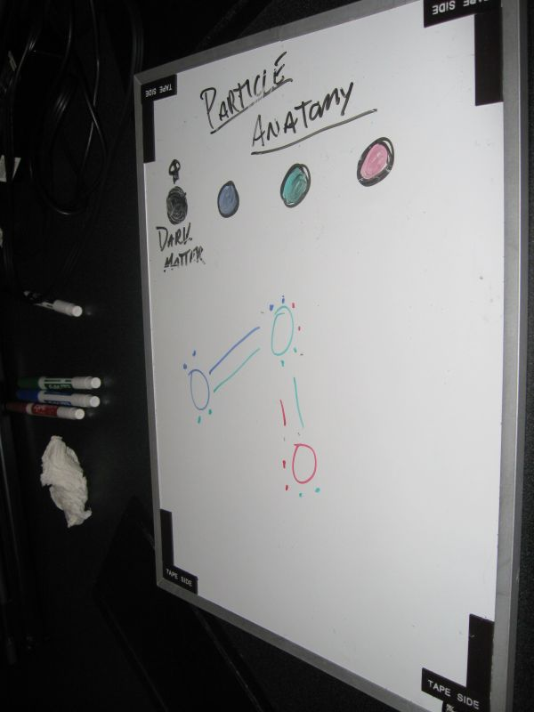
Name/ID
Level 2

Goal
Connect the two atoms as shown by the temporary bond.

Brief Description
The player is introduced to the Connect the Dots mode in this level. They will also learn that dark matter is a hazard and will reduce their energy if they travel through it. The Slingshot action will also be introduced to the player, which will help them to navigate around the level.

Visual Design
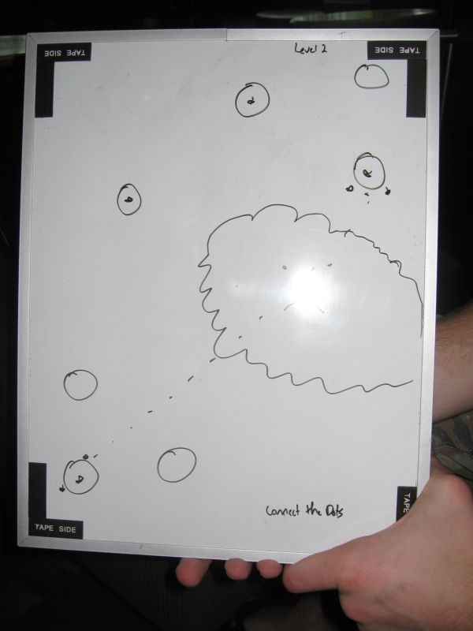
Art and Production Design

Art & Animation Style

All of the 3D deliverables for Particle Panic! will be spheres except the Dark Matter, which will be a gelatinous blob of black and purple made out of a cube with shaders applied.
For the HUD, we will need three circular displays that will look similar to our atoms in the game itself. Each of these displays will have a numerical display inside telling the player how many more of the corresponding color they need. We will also need a circular display broken into three parts for the polarity wheel (red, green and blue) and an arrow that we can move over it to adjust the visual output. The colors should gradient into each other. We will need a horizontal tube-like display that will fill and ebb with our energy count. The filled portion should be neon yellow.
For our models we will need textures that reflect the ambient, energetic feel of our game. We will need them for the three main atoms: red, green and blue. They should also look appropriate with higher levels of alpha, as we are planning to have them translucent. We will also need a background for our ‘particle universe’ that is unobtrusive but compliments the style of the other graphics. It should be dark, predominantly black, but have colored area to give it a sense of depth. This should not be so bright as to clash with the atoms, but should break up the monotony.
For the menu, we will need a simple, clean, round font that we will be able to use for bitmapping our text. It should be easy to read, but not clash with the other visuals, as we will be overlaying the menu at points with our other graphics. It should also be able to be resized properly without any graphical artifacts present or abnormalities in display.

Sound Effects Style

Similar to the music, the sound effects should be mostly of a serene nature, very round and warm, and give the feeling of energy. There should be sound effects when in the area of effect of the atoms that gives the impression of being enveloped by calm, warm energy. When bonds are formed, however, there will be a visual electrical discharge, and that should be a very sharp and natural electrical sound. When picking up the electrons, they should make a soft popping noise, simply to alert the player that they have acquired them. A similar noise should designate their dropping, just at a lower tone. The menu will also feature this sort of soft pop to assure the player they have arrived at a new item. The only sound that needs to be intentionally harsh will be the one associated with running into the Dark Matter. The sound associated with it should be sharp and make the player uncomfortable with having done this. We will also need a sharp beeping sound for when the energy gauge is nearly depleted.

Music Style

The music in Particle Panic! will be ambient techno. When the player is in a Connect the Dots or Builder mode, the feel of the music with be tranquil and trance-like. This will help to create an explorative atmosphere for the player, making them feel at ease with what they are doing. In the time attack mode, the mood of the music will change to a more upbeat, intense, and hardcore style. This will give the player a sense of urgency. As time runs down, more tracks will be overlaid to alert the player of time running out.

Example Songs
- Inbetween Your Choice – 16B
- Keep On Changing Shape – 16B
- Colours – 16B
Storyboards and Sample Art
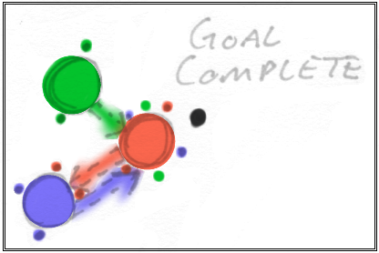
Sample Level Walkthrough
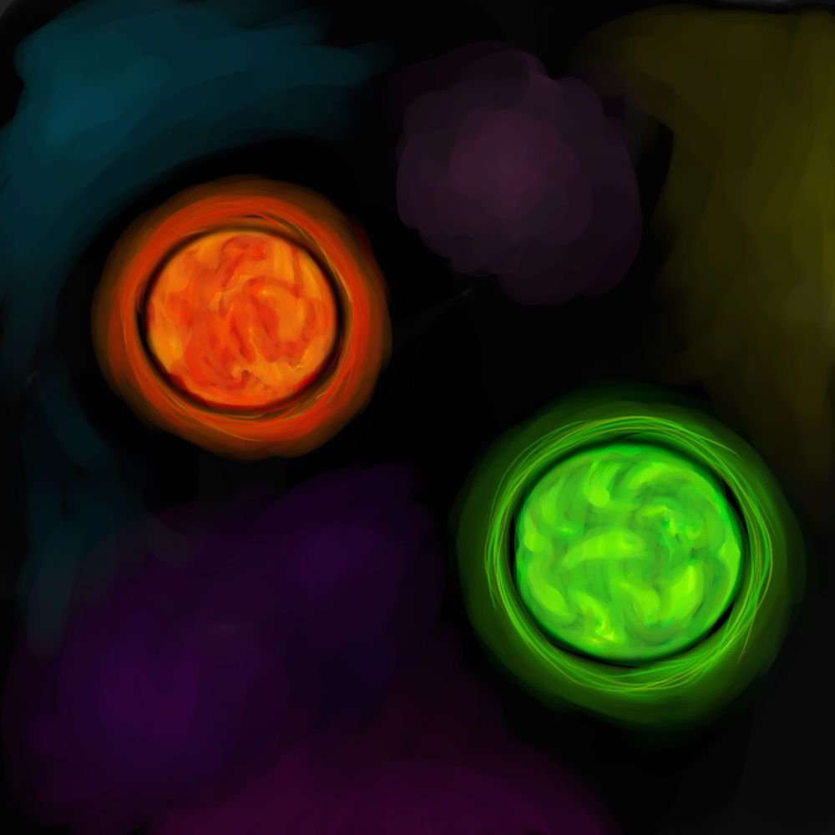
Red and Green Atoms

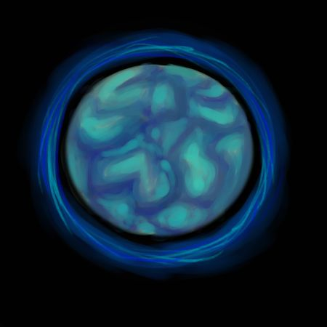
Blue Atom
Quark (with implied shader animation)

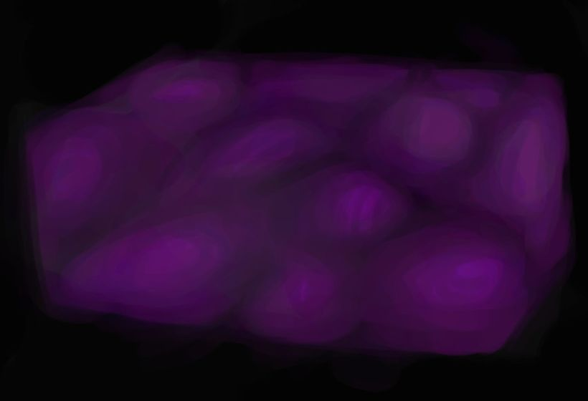
Dark Matter (with implied shader morphing)

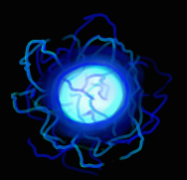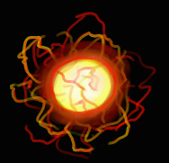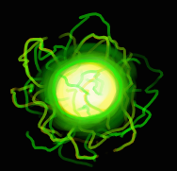
Blue, Red and Green Electrons

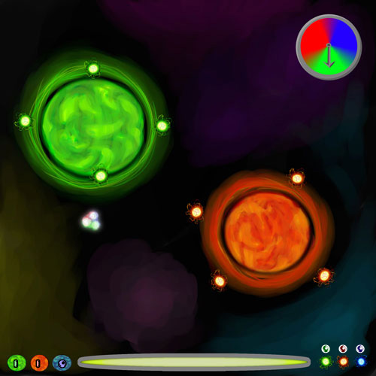
Navigation Mode HUD Mock-Up
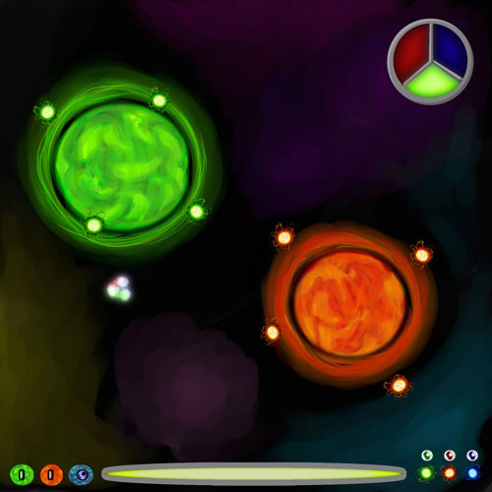
Collection Mode HUD Mock-Up

